**OFFICIAL INTERNATIONAL PUBLICATION OF THE ASSOCIATED LOCKSMITHS OF AMERICA, INC.**

***An International Association of Security Professionals***



O

r-

o

0

1

NO

CO

o

CO

Cl. O  
£:rs.  
l<ro<r  
f ^ urN. o

: <n

Xh~

1^02: **JosXi** <r |LU

[uiOh  
|CQu_ <C

[I



'ritycertified security cert

ECURITY CERTIFIED SECURITYd LIED SECURITY CERTIFIED SECU| JRITY CERTIFIED SECURITY

M UMi]

ECURITY:

ICATION

NCE

F FOR YOU.

**BY RANDY SIMPSON, CML**

uni

PLUS:

* SCHLAGE EVEREST
* ILCO 4000
* GARDLOK 300



M U Ni]

Mil Ul]



BEFORE ANYONE ELSE FINDS OUT, LOOK INTO SAFETECH 2001.

When professionals don't keep up with the evolution of their industry it shows.  
It shows in loss of business, of revenue, of customer confidence.

Focus on where your professional future is going at SAFETECH 2001 in St. Louis, Missouri.

In a city that fires the imagination, you will discover safe technology advances you never imagined possible.  
For more information call 214.827.7233, or email [convention@savta.org](mailto:convention@savta.org).

SAFETECH 2001—A Safe Odyssey.

SAFETECH

**2001**

**A SAFE ODYSSEY**

ST. LOUIS, MO APRIL 30-MAY 5



The Need for Accident & Health Coverage

Every six minutes, an accidental death occurs in the United States. In one day, over 250 people will die in an accident.1 The increasing number of accidents that have given rise to these statistics make having accident insurance a necessity.

Accidental Death and Dismemberment Insurance, Your Best Choice!

The Accident and Health Division **of the member companies** of American International Group,

**Inc. (A1G)** can help you protect yourself as a member of Associated Locksmiths of America from the costly effects of a serious accident. A serious injury or the accidental death of a wage earner can be devastating. Home mortgage payments, college education costs, retirement savings, and childcare may all be jeopardized if there isn’t enough resources to help provide the security that you need. With **Accidental Death and Dismemberment Insurance** you can have the financial securi­ty that you need at an economical cost.

Our **Accidental Death and Dismemberment** coverage meets your needs by offering members of the Associated Locksmiths of America a policy with stand-alone AD&D Benefits. We provide 24-hour, worldwide coverage and many optional benefit enhancements.

Associated Locksmiths of America has been able to customize the policies for their members with many benefits and services including:

The AIG Life Companies (U.S.), members of American International Group, Inc. (AIG), include AIG Life Insurance Company (AIG Life), Wilmington, DE: and American International Life Assurance Company of New York (AILife), New York, NY. AIG, our parent company, is the leading U.S.-based international insurance organization.

AIG Life and AILife have each earned the highest possible rating from three principal rating companies:

* AAA Extremely Strong by Standard & Poor’s**\*** (insurer financial strength and claims-paying abilities);
* Aaa Exceptional by Moody’s**\*** (financial strength); and
* **A++** Superior by A.M. Best (operating performace and financial strength).

*Rated with the support of American International Group, Inc.

* Accidental Death
* Paralysis
* Accidental Dismemberment
* Exposure & Disappearance

Associated Locksmiths of America, Inc. 3003 Live Oak Street Dallas, TX 75204

National Safety Council Accident Facts, 1997



The AIG Life Companies (U.S.)

March 2001

***Keynotes*** li

Contents

**March**



Features

4

President's Journey

By John Greenan, CIVIL, CPS

14

Cover Feature

Selling Security:

How Certification and Insurance Can Pay OfiF for You

By Randy Simpson, CML

18

Bringing Back the Loyalty

Schlage's Everest is a testament to the power of sharing information.

By Don Dennis, CPL

GardLok 300 Series

A technical explanation of the servicing and installation requirements of one of the electronic sets that work well in tight spaces.

By Sal Dulcamara, CML

Best of Baltimore

Have you reserved a spot at the ALOA 2001 Security Expo in beautiful Baltimore - just some of the reasons you should register for convention today.

By Claire L. Cohen, CML

Legislative Update

Check the latest on legislation affecting the security profession near you

By Tim McMullen

22

llco 4000 Series

Take a look inside this popular electronic set. Installation, servicing and more.

By Sal Dulcamara, CML

28

32

34



***Keynotes***

March 2001

|  |  |
| --- | --- |
| T? - , , * | Board |
| f .executive |  |

|  |  |
| --- | --- |
| Editor | Jim DeSimone [editor@aloa.org](mailto:editor@aloa.org) |
| Technical Editor | David Lowell, CML, CMST [david@aloa.org](mailto:david@aloa.org) |
| Editorial Advisor | John D. Cannon, CML j dcannon @ worldnet. att. net |
| Art Director | Lindsay Magers [lindsay@aloa.org](mailto:lindsay@aloa.org) |
| Advertising Sales | Susan Haverkamp  121 Davis Street Nacogdoches, Texas 75961 Phone: (936) 569-7172 VoiceMail: (208) 248-8893 e-mail: [adsales@aloa.org](mailto:adsales@aloa.org) |
| Contributing Editors | Paul Chandler, CRL  Claire Cohen, CML  Sal Dulcamaro, CML |
| Contributing Authors | Jerome V. Andrews, CML Brian Costley, CML, CMST Ray D’Adamo, CML  Daniel Graffeo, CRL, CMST Wayne Gurnee, CRL  A.J. Hoffman, CML  Ken Holmlund, CRL  Ray Lusk, CML  Randy Simpson, CML  Robert Stafford, CPL  Dave Thielen, CML |
| Executive Director | Charles W. Gibson, Jr., CAE [charlie@aloa.org](mailto:charlie@aloa.org) |
| Meetings Manager | Kelly Carr, CMP [kelly@aloa.org](mailto:kelly@aloa.org) |
| PRP/Education Manager | David Lowell, CML, CMST [david@aloa.org](mailto:david@aloa.org) |
| Operations/Membership Manager | Mary May [mary@aloa.org](mailto:mary@aloa.org) |
| Director of Information Technology | Randy McChristian [randy@aloa.org](mailto:randy@aloa.org) |
| Government Affairs Manager/ Chapters & Regional Associations Liaison | Tim McMullen [tim@aloa.org](mailto:tim@aloa.org) |
| Comptroller | Kathy J. Romo |
| Network Specialist | Greg Jackson |
| Membership Coordinator | Shelly Jett |
| PRP/Education Coordinator | Ashley Manson |
| Accounting Coordinator | Kathy Stokes |
| Mail Room Coordinator | Humberto Cerda |
| Receptionist | Alin Valdez |

Additional contact information for the ALOA Board and most Keynotes authors is available through "Locksmith Search on the ALOA Web site- [www.aloa.org](http://www.aloa.org) or by contacting the ALOA office at 3003 Live Oak Street; Dallas, TX 75204; (800)532-2562; FAX (214)827-1810; e-mail [aioa@aioa.org](mailto:aioa@aioa.org).



Mission Statement: The Associated Locksmiths of America, Inc. is dedicated to enhancing the professionalism, education and ethics among locksmiths and  
nose in related sectors of the physical security industry. With approximately 10,000 members in the United States, Canada and the freeworld, ALOA is poised to  
:elp members obtain the knowledge, the strength, and the confidence to perform their role in the physical security field with pride and dignity. But it is only  
irough active involvement and participation that ALOA can fully achieve its potential—and can help members to achieve theirs.

?olicies: Keynotes® is the official publication of the Associated Locksmiths of America, Inc. (ALOA). Keynotes® acts as a moderator without approving,  
lisapproving, or guaranteeing the validity or accuracy of any data, claim, or opinion appearing under a byline or obtained or quoted from an acknowledged  
.ource. The opinions expressed by the authors do not necessarily reflect the official views of ALOA. Also, appearance of advertisements and new products or  
service information does not constitute an endorsement of products or services featured by the Association. The Association does not accept responsibility for  
he inaccuracy of any data, claim, or opinion appearing in this publication, due to typographical errors on the part of the authors, Association staff or its agents.  
Editor’s Note: This publication is designed to provide accurate and authoritative information in regard to the subject matter covered. It is provided and  
disseminated with the understanding that the publisher is not engaged in rendering legal or other professional services. If legal advice and other expert  
Assistance is required, the services of a competent professional should be sought.

Authors’ Payment: Payment for eligible submissions to Keynotes will be based on the following criteria: topic, time spent and past contributions. Authors who  
■egularly submit to Keynotes are generally paid a higher rate. The latter is especially true of authors who write to fit specific editorial needs and submit said copy  
by Keynotes deadlines. As a general guideline: Average payment for a 750 word, business or 'light' technical article would be $200. Payment for a 1500 word article  
involving significantly higher time and research efforts would be $400.

| Payment will not be offered for articles submitted by ALOA employees or members of the ALOA Board of Directors (unless material is of a technical nature),  
nor for articles submitted by a company that promote that company's products or services. ALOA reserves the right not to pay for articles submitted by an  
individual(s) that promote a particular company’s products or services.

Disclaimer: The Associated Locksmiths of America, Inc., (ALOA), reserves the right to refuse any article for any reason. Additionally, ALOA reserves the right  
to edit, amend or modify any article submitted for publication in order to preserve technical accuracy, clarity, fairness or grammatical correctness. ALOA will make  
•the best efforts to notify the author of any changes. The extent of ALOA's liability for any article or information contained therein will be a notice of correction or  
retraction in the next possible issue.

Keynotes* (ISSN 0277 0792) is published monthly except for the combined June/July issue by The Associated Locksmiths of America, Inc., 3003 Live Oak St.,  
Dallas, TX 75204-6186. Telephone: (214) 827-1701; FAX (214) 827-1810; e-mail [aloa@aloa.org](mailto:aloa@aloa.org). Subscription rates for members—$15.00 per year. Second class  
postage paid at Dallas, Texas. POSTMASTER: Send address changes to: Keynotes, 3003 Live Oak St„ Dallas, TX 75204-6186. © Copyright 1999, All rights  
reserved. No part of the contents may be reproduced or reprinted in any form without prior written permission of the publisher.

President

John J. Greenan, CML, CPS  
(773) 486-2030  
[fsljohn@mindspring.com](mailto:fsljohn@mindspring.com)

Secretary

John D. Cannon, CML  
(703) 960-6413  
[jdcannon@worldnet.att.net](mailto:jdcannon@worldnet.att.net)

Directors, Northeast

John C. Magee, III  
(856) 845-3434  
Peter Sarailian, CRL  
(201) 947-6291  
[psarailian@yahoo.com](mailto:psarailian@yahoo.com)  
William L. Young, CML  
(610) 647-5042

Directors, Southeast

Thomas W. Tate  
(850) 476-4211  
Donald E. Rule, CML

1. 324-2658  
   [rulecml@ebicom.net](mailto:rulecml@ebicom.net)

Directors, North Central

Mark E. Blum, CML, CPS  
(517) 482-5809  
[mblum@arq.net](mailto:mblum@arq.net)  
Tom Ripp, CRL  
(608) 262-3831

Director, South Central

Randy L. Simpson, CML  
(713) 780-7026

Directors, Southwest

Gordon R. Racine, CML  
(719) 384-4707  
[aloaswdir@excite.com](mailto:aloaswdir@excite.com)  
John A. Ilk, CRL

1. 420-2174  
   [getreil@yahoo.com](mailto:getreil@yahoo.com)

Director, Northwest

Scott L. Henke, CRL, CPS  
(907) 248-3785  
[action@alaska.net](mailto:action@alaska.net)

Director, Associate Members

David F. Matthies

(727) 541-5536

[dmatthies@southernlock.com](mailto:dmatthies@southernlock.com)

Trustees

Dallas Brooks

(334) 826-8990

David M. Lowell, CML, CM ST

(800) 532-2562

Breck H. Camp, CML

(770) 455-6244

Edwin Toepfer, RL

(416) 225-5589

Past Presidents

1997-1999 Dallas C. Brooks

1995-1997  
1993-1995  
1991-1993  
1989-1991  
1987-1989  
1985-1987  
1983-1985  
1981-1983  
1979-1981  
1977-1979  
1974-1977  
1972-1974  
1970-1972  
1968-1970  
1966-1968  
1964-1966  
1962-1964  
1960-1962  
1956-1960

David Lowell, CML, CMST Breck Camp, CML Henry Printz, CML Evelyn Wersonick, CML, CPS Leonard Passarello, CPL Joe Jackman, CML Stanley Haney, CPL Louis LaGreco, CPL John Kerr, RL Clifford Cox, CML Charles Hetherington Gene Laughridge William Dutcher, RL Constant Maffey, RL Harold Edelstein, RL William Meacham Robert Rackliffe, CPL Edwin Toepfer, RL Ernest Johannesen

March 2001

Keynotes



with John J. Greenan

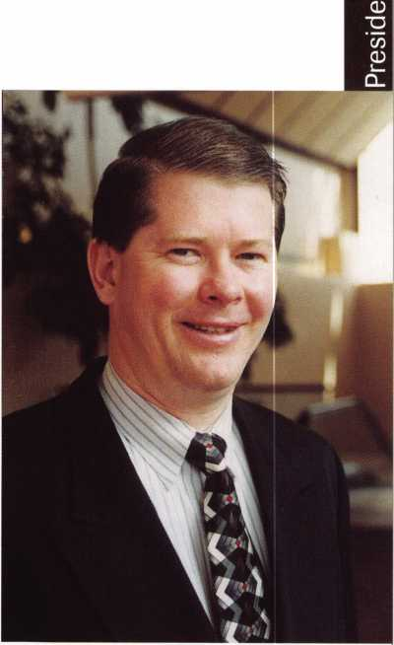

As we settle in for March Madness, it can mean many things to many people. For most, it encompasses the showdown between the 64 college basketball teams down to one undeniable champion. For others, it means hurrying up to get the garden in before its too late. It can even mean that you’ve given up something for Lent, and are going mad! At ALOA, it means getting ready for the 2001 Convention and Security Expo. We start out with more than 64 tasks and nar­row them down to one big championship event:

* Renting the convention hall and rooms
* Putting together the food service for class lunches, receptions and banquets
* Figuring out what the classes are going to be
* Getting the classes together with the convention center for space
* Hiring instructors
* Getting the materials ready
* Preparing for PRP’s
* Putting the brochure together and mailing it out
* Promoting the event
* Getting together the Convention issue of Keynotes
* Packing the office (computers, class materials, safes, handouts, copies of

Keynotes. T-shirts, pins, stickers) on two 18-foot trucks

* Getting advertising in the on-site brochure
* Setting up the ALOA booth

You should have already received your ALOA Convention brochure in the mail, and I urge you to fill it out today and send it in! The convention runs from July 15 - 22, 2001 in Baltimore, Maryland.

Don't miss it!

Sincerely,

John J. Greenan, CML, CPS

*Keynotes*

March 2001



***Visit our Website on  
www. stamcctv. com***

**THE COMPLETE**

**CCTV PROGRAM ON CD-ROM  
FOR STAFF TRAINING AND**

**PRODUCTIVITY ENHANCEMENT**

STAM Insight has been  
developed to enhance CCTV  
skills and productivity with  
many different uses.

**10** Productivity

10 System Drawing  
# Estimation  
10 CCTV Training  
10 CCTV Reference  
10 Sales/Demo  
10 System Design  
10 Staff Evaluation

CCTV Content

CCTV Calculators

Demonstration Tool

Estimation

""

Drawing

Internet Enabled

**Sold in Over 50 Countries**



3003 Live Oak Street  
Dallas,Texas 75204

Name:

Job Title:

Organization:. Address:

Country Tel: (

Zip/Postcode.

e-mail

Fax: ( )

COPYRIGHT © 1996 Security Training and Marketing Pty Ltd. All rights reserved ACN 057 006 541

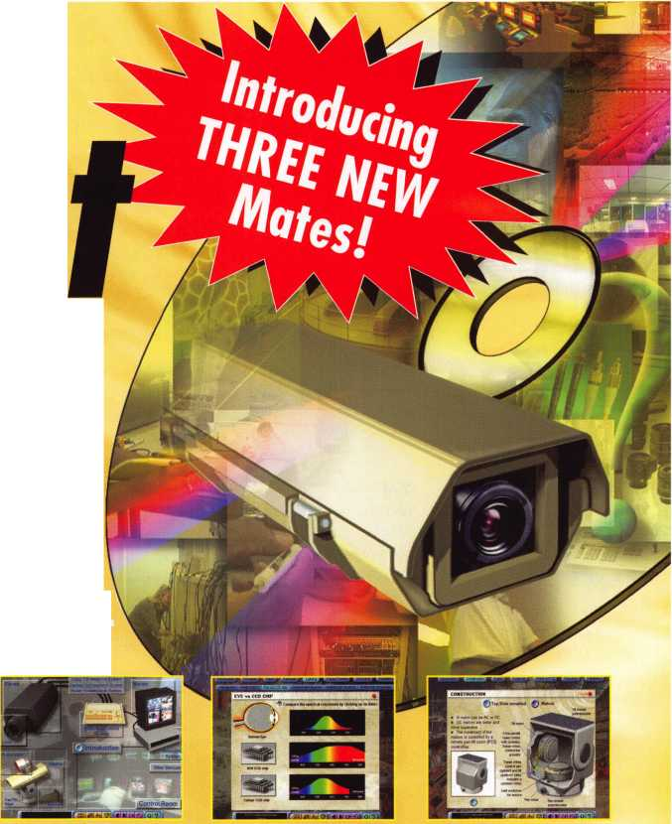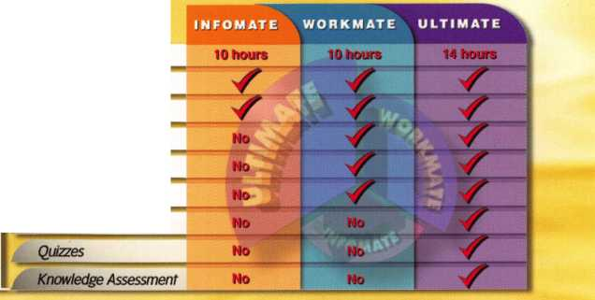

Upcoming

Events

Dept

2001

MARCH

4

Southern Lock Trade Show 2001

St. Petersburg, FL Southern Lock & Supply Co. Contact: Missy Whalen (800) 282-2837

9

f/ ALOA PRP Sitting Dallas, TX

Contact: Ashley Manson (214)827-1701 (214) 827-1810 fax

21-24

CLA 2001 Trade Show + Educational Classes f/ ALOA PRP Sitting Anaheim, CA Disneyland Hotel Californial Locksmith Assocition

Contact: CLA Office-Gen­eral Info (714) 632-6800 Norm Weisenburger-Edu- cation Info (818) 704-6197 Jack Lindstrom-Educa- tion/PRP Info (760) 364-4421

23-25

ALOA Spring Board

Meeting

Dallas, TX

30-31

Lousianna-Mississippi Locksmith Association Inc.

Spring Education Meeting Holiday Inn Hammond, LA.

Contact Glen Sawyer 101 Carter St.

Vidalia, LA. 71373

28-April 1

MLANJ 2001 Annual Convention

Ace Classes (17) f/ PRP Sitting Somerset, NJ Convention Contact:

(973)267-8884 (973) 538-2248 fax

[www.mlanj.org](http://www.mlanj.org) PRP Contact:

Dan McGlynn, CML (732) 634-4605

April

i

f/ ALOA PRP Sitting Rosemont, IL Clark Security Products Contact: Joan Emrick (619)718-7308

2-4

ASTM Committee F12 Meeting

Security Systems and Equipment Phoenix, AZ American Society for Testing Materials Meeting Contact: Jim Olshefsky (610)832-9714 [jolshefs@astm.org](mailto:jolshefs@astm.org) Housing: Hyatt Regency (602) 252-1234

4-6

ISC Expo/ West 2001 Las Vegas, NV Sands Expo & Convention Center

13

f/ ALOA PRP Sitting Dallas, TX

Contact: Ashley Manson (214) 827-1701 (214) 827-1810 fax

14

f/ ALOA PRP Sitting White Bear Lake, MI Minnesota Chapter of ALOA

Contact: Alan Morgan (763) 566-2637

30-May 5

SAFETECH 2001 St. Louis, MO (214)827-7233

MAY

10-13

f/ ALOA PRP Sitting IDN 2001 Trade Show & Security Conference Ypsilanti, MI Contact: Fred Strasberger (800)521-0955 or

Bonnie Weston (734) 591-1150

11

ALOA PRP Sitting Dallas, TX

Contact: Ashley Manson (214)827-1701 (214) 827-1810 fax

JUNE

3

North Jersey Master Locksmith Association will be having its 7th Annual Flea Market and Swap Meet at the Quality Inn Lyndhurst, New Jersey .

Call

(201)944-7547

8

(f ALOA PRP Sitting Dallas, TX

Contact: Ashley Manson (214)827-1701 (214) 827-1810 fax

24

ALOA PRP Sitting Sacramento, CA Clark Security Products Contact: Joan Emrick (619) 718-7308

JULY

13

f/' ALOA PRP Sitting Dallas, TX

Contact: Ashley Manson (214)827-1701 (214) 827-1810 fax

15-22

ALOA 2001 Security Expo

Baltimore, MD (800)532-2562

AUGUST

10

fjt ALOA PRP Sitting Dallas, TX

Contact: Ashley Manson

Indicates ALOA ACE Class r Indicates PRP Sitting

2002

JULY

22-28

ALOA 2002 Security Expo

Rosemont, IL (800)532-2562

OCTOBER

12

f/k ALOA PRP Sitting Dallas, TX

Contact: Ashley Manson (214)827-1701 (214) 827-1810 fax

15-21

Tri Regional Locksmith Conference Portland, OR Pacific Locksmith Associa­tion

Contact: Stan Hauer (503)325-7334 Email [hauer@pacifier.com](mailto:hauer@pacifier.com) Contact: Ken Mead (503)873-6932

(214)827-1701 (214) 827-1810 fax

SEPTEMBER

14

ALOA PRP Sitting Dallas, TX

Contact: Ashley Manson (214)827-1701 (214) 827-1810 fax

NOVEMBER

7-11

2001 Yankee Security Convention

Sturbridge Host Hotel Sturbridge, MA. 01566

9

f/ ALOA PRP Sitting Dallas, TX

Contact: Ashley Manson (214)827-1701 (214) 827-1810 fax

DECEMBER

14

ALOA PRP Sitting Dallas, TX

Contact: Ashley Manson (214)827-1701 (214) 827-1810 fax

*Keynotes*

March 2001



“If you want to study for the CPS test,

you need this book.

Without that book, I wouldn’t have my certification.”

-Dennis Johnson, CML, CPS  
Aurora\, Illinois

"Mike's new book is very  
consistent with the study  
information required to pass the  
SAVTA/ALOA CPS certification  
test I wouldn't have passed  
without it. *A tremendous  
resource for today  
and tomorrow..."*

-John T. Grist, CML, CPS  
North Georgia Security

"The Safe Technicians Reference Manual by Mike Oehlert ranks among the best technical reference and learning aids you will find in the safe and vault industry. It contains page after page of essential information and easily understood illustrations. Besides answering most of the questions commonly asked by technicians new to the field, Mike has also included plenty of information experienced technicians will find useful."

-Ken Dunckel Pacifica, California

—►Over 600 Illustrations.-*—

320 **pages.** Only $**135**.

What are you waiting for?

To order, call 800-532-2562. Allow 3 weeks for delivery.

All major credit cards accepted; or make check payable to ALOA.

The Safe

Technicians  
Reference Manual

First Edition

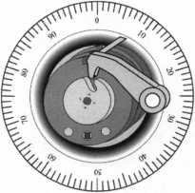

March 2001

Keynotes

* Houston Homeowners

Southwest Houston homeowners could save as much as 20 percent yearly on their home insurance rates, with a free security inspection offered by the Houston Police Department. “The total reduction of 20 percent is available for home owners who comply with all provisions of the offer, which includes security hardware and alarm system,” said Houston Police Officer Chris Engelhardt, of the Westside Com­mand Station, 3203 S. Dairy Ashford. Engelhardt said the Westside Commands staff of four officers assigned to the Com­munity Services section will arrange for a safety inspection if the home or condo­minium owner makes a request by calling 281-584-4957. The inspections usually take only 15 or 20 minutes since the officer handling the request will advise the caller what steps to take to meet security specs before he makes the actual inspection,” Engelhardt said. Inspections can be requested for convenient times, weekdays or evenings and even on weekends. There is no charge for the service which could save the average homeowner between $ 100 and $ 200 a year in insurance payments, while renters could benefit in reductions on their insurance of household belongings. West- side Commands Station provides police protection to the southwest Houston area which extends as far north as Interstate-10, east to the Galleria and south and west tothe Fort Bend County line. “This is not a new service,” said Engelhardt. “In fact the department has been performing the ser­vice for about 10 years. But not everybody is aware of its availability.” The Houston police officer said the inspections do not include checks of fire-alarm systems.

* State of Texas Locksmith Garage Sale

The San Antonio Locksmiths Association is sponsoring a Locksmith Garage Sale on March 24, 2001 in Fredricksburg, TX. Many different items will be available and all proceeds go to the Texas Legislative Fund. Tables are available for $10 and admission is free to shoppers. Lots of food

will be available as well. For more informa­tion, contact Mike Clark,

210/923-4381.

* New Brinks Home Security, Inc.

Home Security, Inc. recently appointed Stacey Rapier as Vice President of Human Resources of the Irving,Texas-based com­pany. Stacey brings over 14 years of experi­ence as a recognized human resources exec­utive. Most recently, Stacey was Vice Pres­ident of People and Corporate Services at the MARC Group. Previously, she was Vice President of People Development at AT&T Wireless Services and held various posi­tions at the NCR Corporation

* CLA Adds Classes to 2001 Trade Show

The California Locksmiths Association (CLA) will hold its Trade Show March 21- 24, 2001 at the Disneyland Hotel in Ana­heim, California. In order to incorporate this years them “Power of Education,” education classes have been added to the event. Due to tremendous demand the following classes have been added: Abus Padlock Certification, An Introduc­tion to Access Control and Systems Design, Auto Opening, Electronics 101, and a Safe class. Contact CLA President, Norm Weisenburger at (818) 704-6197 or Convention Education Chairman, Jack Lindstrom, CCL at (760) 364-4421 for more details regarding the education program.

* Panasonic New Group Manager

Panasonic Security Systems Group has appointed Neil Heller to the newly created position of Group Manager, Product Man­agement. Helleris primary function will be to enhance sales and positioning of Pana­sonic CCTV products. He will also be actively involved in all marketing and product management activities, while proposing new products for the market and developing product support materials, market intelligence, competitive product

core

analysis and training programs. Prior to joining Panasonic, Heller was a regional manager for Sensormatic. He previously held the position of National Product Mar­keting Manager for Sanyo Fisher Company, where he was also involved in product development at the factory level.

* Briefs

American Fibertek announced the appoint­ment of Ray Sooley to the position of Director of Sales. Ed Davis, vice president of American Fibertek, made the announce­ment from the company is New Jersey headquarters recently, citing Sooleyis expe­rience in the security industry and Ameri­can Fibertekfsgrowing security market as reasons for the appointment. Sooley has 25 years of industry experience, including 16 years in closed circuit television (CCTV). Prior to his latest post, Sooley was at Ademco Video Products Group, where he was responsible for applications engineer­ing, tech support and the marketing/com­munications departments. He has also held various positions with American Dynam­ics, Ikegami Electronics (USA) and Vision Research Corporation.

* Regions

OMLA Annual Trade Show & Class

The Oklahoma Master Locksmith Associa­tion (OMLA) will hold its February Trade Show & Class on February 17, 2001 at the Holiday Inn Select, 5000 E. Skeiiy Drive, Tulsa, OK, (800) 836-9635.The trade show will run from 9:00 am until 4:00 pm. However, a free deli lunch will be pro­vided. February’s class will be on Arrow Try-Out Keys. For

additional education information contact: Jerry Rice at (405) 741-7485. For addi­tional trade show information contact: Mike McGrew at (918) 333- 9136. If you can’t make this one mark your calendars for the next class to be held on May 6. This class will be taught by D.W. Dallas and will include safe opening and tricks of the trade.

*Keynotes*

March 2001

•Obits

William H. Welke, RL

With regret, we announce the sudden passing of William Welke, RL, ALOA Chartered Life Member number 248. A retired security systems engineer from Argonne National Laboratory, Welke was among the very first ALOA members, joining in the first year of ALOAis exis­tence, 1956. A World War II veteran, he served on active duty from March 5, 1941 to Nov.l, 1945. Born in Chicago on March 31, 1916, he lived in Matteson, 111. For some 30 years.

Edwin Scott Jr.

We regret to announce that longtime member and locksmith pioneer Edwin Scott Jr. recently passed away.

He began his career in the U.S. Navy, where he found himself in Treasure Island, California, for training. Soon he was work­ing with the carpenters on base there, and this experience taught Edwin the funda­mentals of locksmithing. It would be his lifelong passion and span some 50 years. He established the Golden Gate School of Lock Technology, and became the first res­idential locksmith in the United States certified in the state of California. The school has trained over 100 students per year throughout the world, including South Korea, Africa and Canada. He also authored six books, including a locksmith dictionary.

• PRP

At the TLA Convention in February, sever­al new members received PRP certifica­tions. They are:

CIVIL

Joseph Fuller

CRL

Ruth Davis Robert Fleener Barry Pusatgeri

ALOA offers PRP/STPRP Testing every second Friday of the month at the ALOA Headquarters. We are located at 3003 Live Oak Street; Dallas, Texas. For more information contact:

Ashley Manson at (214) 827-1701 X30.

We would like to congratulate the follow­ing individuals who recently achieved PRP/STPRP designations.

CRL

Cypert, Alien, Wahiawa, HI Deck, Michael L., Crossville, TN Donohoe, Brian, Raleigh, NC Garcia, Richard, Makailo, HI Ling, Nathan, Honolulu, HI

Melvin, Christopher J., Phoenix, AZ Selent, Joseph, Otsego, MI Trepanier, Eric, Richland, MI

CPS

Pielech, Joseph, Tucson, AZ

It's True

Marrcty has developed the first  
screwless door loop.

Standard 18” length. Can be ordered in cus­tom lengths

Plastic base stops shorts and pro­tects wires

Screwless base and cap means you drill two 1/2 inch diameter holes, pop the base into the hole, wire your system and snap on your covers. Simple as 1,2, 3.

**Here’s the best part We are giving away a**

FREE SAMPLE TO THE FIRST 1 OO CALLERS WHO MEN­TION THIS ADD. A $14.40 WHOLESALE PRICE VALUE.

CALL TODAY, IT’S FREE!!

1-800-500-1449

Marray *enterprises, inc.*

At Marray, we’re not just modifiers, we’re Master Hardware Modifiers™  
1128 Walsh Ave., Santa Clara, CA 95050- [www.marray.com](http://www.marray.com)

Aluminum ma­terial means true anodizing.

No off color powder coat­ing or painting

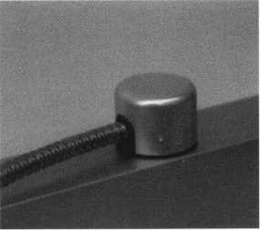

March 2001

*Keynotes*| 9

|  |  |
| --- | --- |
| Security |  |
| Marketplace |  |



Dortronics Power

Dortronics Systems, Inc. has begun ship­ping its new series of power supplies employing advanced features and door control/alarm systems integration capabil­ities. The new 4200 series power supplies offer field selectable 12 or 24 VCD opera­tion and integrate a fire alarm release, alarm output relays, and low battery noti­fication functions. Models are available in two and four amp versions to accomodate various door lock and alarm applications. The series is available in two models: the 4202 (featuring a 2-amp output designed for single and double electronic door lock installations) and the 4204 (featuring a 4- amp output for installations with multiple door locks and additional security devices. For more information, check [www.dortronics.com](http://www.dortronics.com), or call 1-800-906- 0137.

Streamlight Schemes

|  |  |
| --- | --- |
|  |  |
| I1HKI& |  |

Steamlight, Inc., recently introduced BatonLite, a self-desfense tool that is com­bined with a high-intensity LED flash­light. The BatonLite was introduced at the 2000 IACP conference in San Diego last November, and as far as anyone could tell, it beat the lights out of the competition. The BatonLite is designed to offer law enforcement professionals a multitude of features not previously available in a single device. With a super bright light beam and baton styling, the BatonLite is meant to complement an officer’s standard issue equipment.

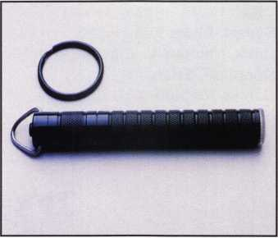

Streamlight has also introduced the Digi­tal Flasher/Dimmer Tailcap for its SL-20X and SL-35X flashlights. The new accessory, according to company president Brad Pen­ney, is ideal for law enforcement, and enables users to adjust the beam from a high-intensity stream to a low level light­ing. Also notable is a flash mode of the tailcap. This strobe feature is designed for use in traffic control situations where extended run times are needed. For more information go to [www.streamlight.com](http://www.streamlight.com) or call 1-800-523-7488

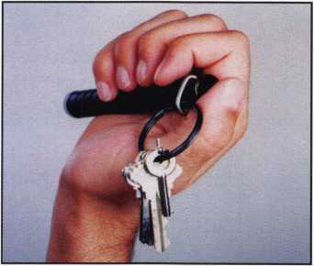

Fiberlek Transceivers

American Fibertek, Inc. is offering a series of low cost fiber optic transceivers for CcTV systems applications that deliver near broadcast quality. The versatile Ml00, M300 and M300S Single Channel FM Video Transmission Systems are designed to offer transparent operation with many manufactuers’ CCTV cameras

and monitors. The units are offered in low profile and stand-alone modules, or in rack cards for use with rack mountable card- cages. For more information, go to [www.americanfibertek.com](http://www.americanfibertek.com), or call 1-732- 302-0660.

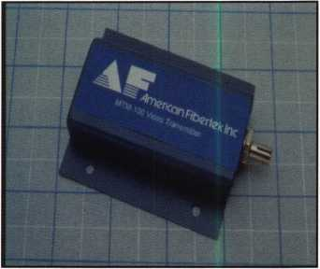

Adventure ISC

Invention Submission Corporation (ISC) recently announced that one of its inven­tors from South Carolina has developed a new door lock designed to make a keyhole easier to view when unlocking a door at night.

The Adventure Door Lock would illumi­nate the lock automatically at night. Developed with safety in mind, the unit would help a person get into a locked home in seconds, without fumbling to get the key in the lock or struggling to illu­minate it with a lighter or penlight. The hands-free design of the Adventure Door Lock would be especially convenient for someone loaded down with arms full of groceries and other purchases.

For more information, write Dept. 99- CHR-630, ISC, 217 Ninth Street, Pitts­burgh, PA 15222, or call (412) 288-1300 ext. 1368. (B.C.)

I *Keynotes*

March 2001

* Super bearing construction.
* Superior rigidity and accuracy.
* Shipped with carbide cutter.
* 2 year parts and labor warranty.
* Increased cut rates:

Laser mode 8 seconds.

Standard mode 12 seconds.

Bi Axial 6 pin 17 seconds.

* New Medeco Autoswing head option.

WEAR EVE PROTECTS

* Up to 800 built-in manufacturer depths and spaces.
* Works with most popular Master key systems.
* Serial port to communicate with user systems.
* Repeatable accuracy of l/1000th inch.
* Dependable heavy duty construction.
* 1 year parts and labor warranty.
* Cuts Medeco™ High Security keys with angled cuts.

The ITL 9000 was built by locksmiths — we know what you wanted so we built  
it. When a new lock comes out you add the space and depths immediately. No  
Mechanical adjustments. All sealed and prelubricated bearings.

ITL-9000

WEAR EYE PROTECTION

* Uses either 12 or 120 volts.
* All manufacturer depths and spaces built in.
* Heavy duty construction.
* 12 month warranty.
* Built in Master key System.

**TOOLS LIMITED**

— **Now Distributed Throughout USA, Canada 8e Australia** —

2639B Progressive Way • Abbotsford, BC Canada V2T6H8  
USA: 562-699-0060 • Canada: 604-852-8904 • Canada Fax: 604-852-8938 • Toll Free: 1-888-264-6627

Keynotei

March 2001

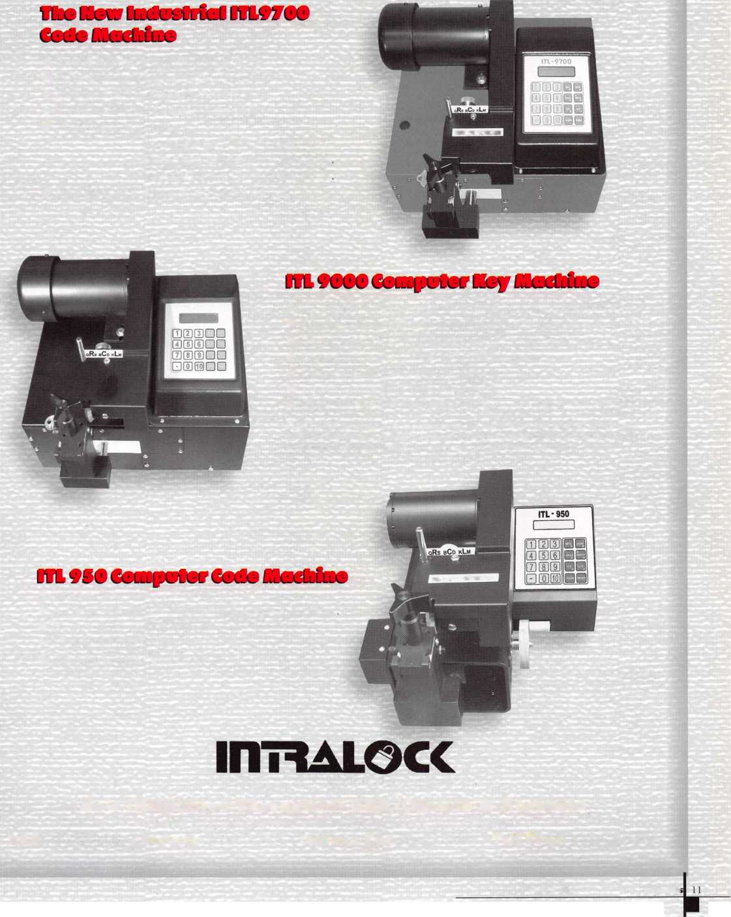

Applicants

For Membership

Dept

***The following applicants are scheduled for clearance as members of ALOA. The names are published for member review and comment prior to March 1, 2001, respectively, to ensure applicants meet standards of ALOA's Code of Ethics. Protests, if any, should be addressed to the Membership Department and must be signed.***

ARIZONA

Phoenix

J. Michael Erickson

CALIFORNIA

Anaheim

Dan Lilly

Inglewood

Reginaldo Rodas

Napa

Tom M. Wirth

Palm Springs

Larry E. Hinkle Stephen R. Deyo

COLORADO

Colorado Springs

Stephen J. Hassler Robert J. Archer

Denver

Guillermo Duran

Littleton

James M. Thompson

CONNETICUT New Britain

Mellisa A. Griswold

FLORIDA

Miami

Scott Hirsch

Palm Bay

Michael J. Dunlevy

Sanford

David A. Thompson Donald R. Wilson

ILLINOIS

Chicago

Glenn Evans Odell Penson

INDIANA

Indianapolis

Carl Dean

LOUISIANA

Lafayette

Robert J. Reynolds

MASSACHUSETTS

Maynard

William J LaBarge

MARYLAND

District Heights

Edmund Smoot SPONSOR: Henry Raymond

Hagerstown

John A Cliber

Lanham

Jesse J Jackson SPONSOR: Henry Raymond

OHIO

Cincinnati

Charles L. Woods

Northwood

Carol A. Lawson

Portsmouth

Donald A. Stephen

PENNSYLVANIA

Harleysville

Charles D Gulick III

TENNESSEE

Nashville

William JNeeseRL SPONSOR: Ron Harrison

TEXAS

Dallas

Kelly P. Carr CMP Robert A. Ashmore

Dripping Springs

Thomas W. Campbell

Hudson Oaks

Bob McCleary

Lake Dallas

Jeff D. James

Longview

Jonathan P. Martin

VIRGINIA

Alexandria

Robert W Noe SPONSOR: Henry Raymond Mingo Gansonjr SPONSOR: Steve Chabo

WASHINGTON DC Biniyam Geremew

SPONSOR: Philip A. Rovenolt

CANADA

Kaministiquia Ontario

Lauri Sadko

NEW YORK

Roosevelt Osman Sinclair

OKLAHOMA

Bethany

Joshua Powell

OREGON

Bandon

John S. Costa

PENNSYLVANIA

Lebanon

Wayne T. Barr Jr.

Stephen J. Mays

NORTH CAROLINA

Hickory

Eric L Poteat

SOUTH CAROLINA

Hilton Head Island

James M. Bess

VIRGINIA Dale City

Eric W. Calderon

WASHINGTON

Yakima

Rodolfo Ramirez

WISCONSIN

Beloit

Jacob B. Matteson

Markesan

Michael W Ross

Two Rivers

Bmce A Suettinger

UNITED KINGDOM

Braintree Essex

Stuart Phillipson

Weymouth, Dorset

David W Rodgers

Keynotes

March 2001



Keynotes

NEEDS YOUR HELP!!!  
**Authors Wanted**

Share your Knowledge and experience with others in  
the field by writing both technical and non-technical  
features for upcoming issues of Keynotes.

We will send you $$$$$$ for your contribution!

For more information on Editorial Guidelines or

Payment Criteria contact Patanya Johnson,

Managing Editor at (214) 827-1701 Ext. 2

send an e-mail to [keynotes@anet-dfw.com](mailto:keynotes@anet-dfw.com)

Keynotes

3003 Live Oak Street  
Dallas, TX 75204  
(214)827-1701  
(214)827-1810 fax

*Amount is based on length of text and number

included

W

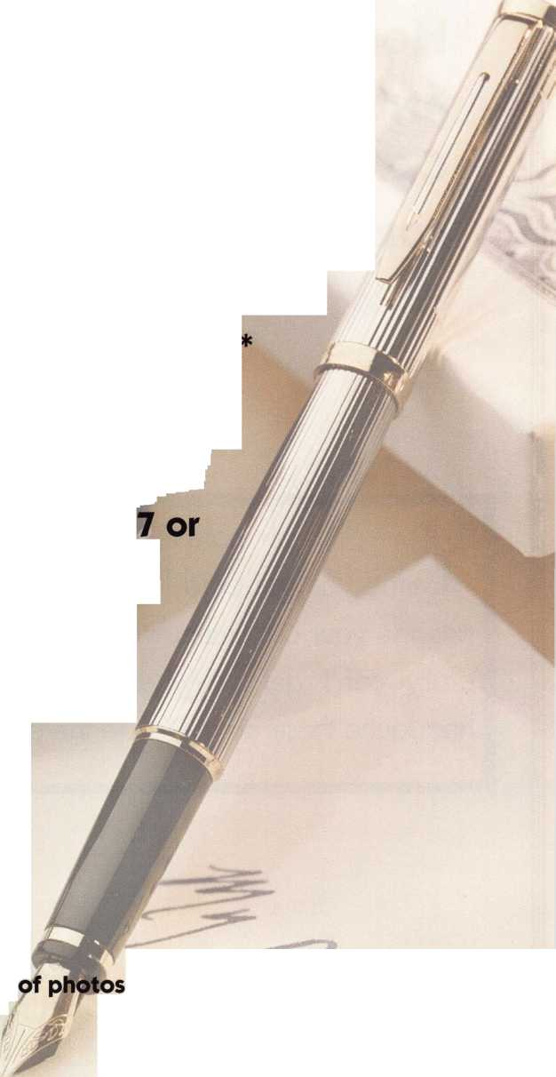

BY RANDY SIMPSON, CML

**How Certifications and Insurance Can Pay Off for YOU.**

Y

ou sell much more than locksmith services - and it's  
time you get paid for it. You sell knowledge; you

provide your customers with a sense of security they lit-  
erally can't get anywhere else. And security is a  
headache these days. You're the painkiller.

*Keynotes*

March 2001

Certification and sales go hand in hand. Customers like guarantees. They are a no brainier. Sears set the standard in what they called their Customer Service Guarantee. If you were not satisfied with any prod­uct you purchased from Sears you could return it, no questions asked. Or call their Certified Service center. How could you go wrong? So why should anyone buy from you? What do you have to offer that the competition doesn't?

Authorized/Certified Factory Service

This one will set you apart. Who do you let work on your Lexus? The guy at the backyard garage or the Lexus Authorized Service Center? Security is an impor­tant issue. The customer would like to know that man­ufacturers certify and authorize businesses and tech­nicians to work on their products. This takes training and certification from each manufacturer. From safes to door locks most manufacturers will train and certi­fy you to work on their products. In fact, most have programs to promote and to refer work to Certified Service Centers. They will give you patches for your shirt. Signs for your truck or business. Some even give you shirts that make you look like you came from the fac­tory. Official-looking, framed certificates authorizing you to work on their products. Oh yeah, even technical service manuals. Let me see: I go to the factory certification class­es, present myself well enough to pass the class, get all this stuff, then go to a customer who has many of the manufactur­ers' products. I tell them, "I am the guy that the factory has sent to work on your products. See this shirt? It says so." The customer sees that you have the factory's approval and you immediately become his best friend.

Manufacturers are desperately searching for local service centers. The con­sumer is asking the manufacturer, "Who do we use to service and install your products?" Certification is a Cart Blanc stamp of approval. Get a few of these diplo- and see who is asking you to do business.

March 2001

*Keynotes*

k-



Certified Locksmith

I've done the work. Persistence paid off. I sat through enough Proficiency Registration Tests to finally pass. Wahoo am I glad. That was tough work. As well it should be.

As an international trade association, ALOA recognizes professionalism and proficiency among locksmiths by granting the designa­tions Registered Locksmith (RL), Certified Reg­istered Locksmith (CRL), Certified Professional Locksmith (CPL), and Certified Master Lock­smith (CML). Available to all locksmiths, the Proficiency Registration Program (PRP) evalu­ates, through participation tracking and test­ing, the educational and technical compe­tence of dedicated individuals in a wide range of subjects such as hardware installa­tion, key duplication, automotive, high securi­ty cylinders, safe and vault locks, master key­ing, alarms, and access control devices.

Registered Locksmith (RL)

The designation for Registered Locksmith is - RL. John Doe, RL, is an active locksmith who has completed a prescribed number of ALOA Education Units (AEU) or has been igrand fathered? into the program. An RL is recog­nized for training or experience, but is not tested or certified.

Certified Registered Locksmith (CRL)

The designation for Certified Registered Lock­smith is - CRL. John Doe, CRL, has passed the ten mandatory categories, as well as at least two specialized electives of his choice. This locksmith has a good working knowledge of

Certified Professional Locksmith (CPL)

The designation for Certified Professional Locksmith is - CPL. John Doe, CPL, has arned the CRL designation and has sue cessfully demonstrated proficiency in an additional twelve elective categories. This locksmith has an advanced knowledge of general lock- smithing and of many specialized areas.

Certified Master Locksmith (CML)

The designation for Certified Master Locksmith is - CML. Randy Simpson, CML, has reached the highest level of ALOA's Proficiency Regis­tration Program. Certified Master Locksmith designates an individual who has successfully completed ninety percent (The percentage was higher when I passed mine because there were less categories.) of the available cate­gories of the Proficiency Registration Program. This locksmith has advanced knowledge of most areas of locksmithing and electronic security

ALOA has certified 3,900 of its members nationwide with an additional 2,500 who are presently in the early stages of certification. ALOA provides the licensing exam for the State of Illinois Department of Professional Regulation and has worked with other city and state agencies in setting up their qualifi­cations for locksmith hiring and requirements for licensing.

If you have any one of these designations make sure your customers know about it. If you Currently have not participated in the program find out when you can.

J Keynotes

March 2001

Certified Discounts

A recent article in the Houston chronicle Head­lines HPD offers home security inspections. Houston Home owners are offered a 20 percent savings on their homeowner's rates if they pass a free security inspection offered by the Houston Police department. "The total reduction of 20 percent is available for home owners who com­ply with provisions of the offer, which includes security hardware and alarm system," said Houston Police Officer Chris Englhardt, of the Westside Command Station. That could be about $150 a year for an average homeowner. Your community should be offering similar inspections. Check with your local authorities and find out. Someone will need to help them comply if their property is not up to the specifi­cations. Houston tells the homeowner what is needed to pass prior to the inspection, which takes about 20 Minutes. They issue a certificate for the homeowner to send to their insurance carrier for the discounts. Tell your customers about the discounts and buddy up the officers who are doing the inspections.

Certified Security

Hello Mister Gates our Preferred Service Pro­gram guarantees you same day service response 24 hours a day 7 days a week. Yes, there may be an overtime charge. Our compa­ny will guarantee repairs to your security prod­ucts so that your property is always secure. Our select security products have a full one year war­ranty on parts and labor.

We will Guarantee them to be free from defects

parts and labor for one full year. Why yes we do have cheaper lower quality locks. No, they are only warranted for 30 days.

By offering a full customer guarantee you have increased the value of the service. Mister Gates may not want to explain to the Microsoft board why he replaced that lock 3 times last year.

By guaranteeing your commitment to his service his worries are turned into satisfaction.

As easy as 1 2 3, Doe Rae Me, and ABC. Cer­tification can help set you apart from the rest of the everyday crowd. Why offer just Security Ser­vice when it could be Certified Security Service?

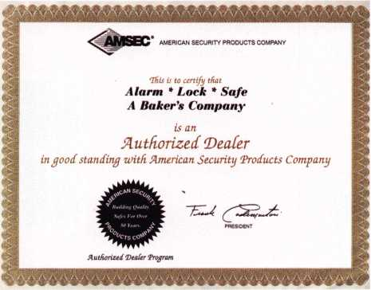

The Associated Locksmiths of America, Inc.

unde**r and by virtue of its ch**arter  
lieFebyrecognTzesThai

IRcmfotj C. §Hnt »crn

tcml r



Certified Ma§Fer Locksmith

**13907**

In Witness Whereof, this Certificate, Signed by the Authorized Officers. Is Granted this the JJ^_dayof 7mA. in the year—1968......

ProBcisncy Registration Committee

March 2001

*Keynotes*

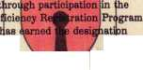

**Bringing**

BACK THE

LOYALTY

BY DON DENNIS,

CPL



©

ID

<



Keynotes

Conveyors are every-

where. Here the overhead  
conveyor system brings

the product

to shipping

What a pinning kit! This is one station at one section of the factoiy where master keying takes place.

A boxed

it's last  
section  
heading

package leaving

tion at one  
the factory

r shipping.

static

of ‘

for

WH* V efore arriving at the last ALOA ■ convention in Las Vegas, I found I that the commercial division of

Mu J Schlage Lock Company was located in Security, Colorado, just outside of Colorado Springs. I was lucky enough to have my self-invitation accepted and it turned out to be one of the best opportu­nities of my trip out west. My real intention was to find out about a thing called Everest. I’m not talking about a mountain, but a keying system that had a cylinder with a special pin and a new patented keyway. I wanted to find out what the company’s dedication was to this new product and what it would mean to my business if I were to embrace it. I was looking for something special that I could use to save on inventory expansion and that will continue to evolve with the times. So many times in the past, I have gotten on board with a new product and new company only to find disappointment and lost profitability.

I wanted a product and a backing of a company that my business and I could depend upon. It is like thoughts of investing in the stock markets. You don’t go out and invest in a dot-com unless it shows you the right numbers that will make your investment grow. After my visit to the factory and in doing research into Ingersoll-Rand’s concept and product (the corporate owner of Schlage), do I feel good about writing that Schlage has my vote of confidence. It also has a spot in my inventory and business growth.

The factory was a wonderful working exhibit of technological concept and function. I had never witnessed a factory that flowed from one worksta­tion to another with such completeness and success in task. As locksmiths we witness a lot of manu­facturing plants in our daily work and even our home television sets have programs now on the manufacturing of products, but nothing like what I witnessed at Schlage. The conveyors were moving product from one function of manufacturing to the next and finally depositing the boxed product to a specific location in shipping. The entire movement of the factory was united in function as if it were a human body, with all of its elements, going through a motion of work. It was beautiful to the eye and senses. When one sees something like this

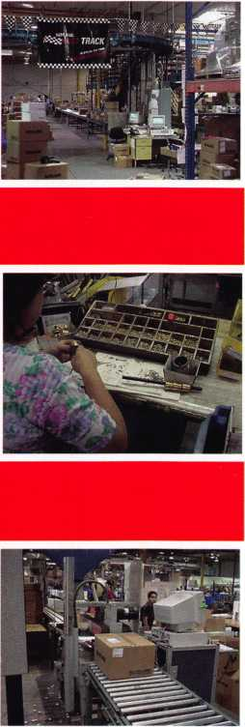

occurring in the production of a product, you can only feel confident in the end product. With that said, let’s look at the product.

**Everest**

I said earlier that Everest was my major concern with this trip and with this article. I wanted to see if Schlage was doing enough for me to consider calling its efforts as a come back, a redefinition, a new commitment. I wanted something more solid for a business platform.

High Security is not really my major concern even though it has a well-defined application and purpose. Primus, in other words, has its place in the scope of business but I have found high security to be narrow in concept since it gives key control while presenting a high cost to the customer. I wanted something for everyday purposes and application. I wanted something, which would not require a heavy expenditure and volumes of stock. I wanted it to be easy to acquire parts and pieces. I wanted key control at a reasonable cost. It needed to be a cost that would not embarrass me when I approached a customer. I know I have a lot of “I wants” but I want!

I think that when we want to address the subject as to what is the difference in Everest, we need to make the comparison with what we already know. We know about what Schlage is calling the Classic key ways. I wonder if they decided to call it classic like Coca-Cola decided to call their old product Classic? Anyway, what Schlage interprets, as Classics are the old keyways from the “C” through the “L.” You can remember the old pyramid, which had the “L” keyway at the top and the “C” keyway through the “G” keyway on the bottom. The “H,” “J,” and “K” were in the middle of the pyramid as the submaster sectional blanks. If this is Greek to you, then look at your key blank book and under Schlage you will see the pyramid that I’m speaking of.

Everest has the same type of pyramid only with 10 open keyways. I say open as opposed to restricted. Open is interpreted as those keyways that can be used by the locksmith. The restricted keyways are another matter that

will exist between Schlage and the end user. Therefore, I’ll not address the restricted other than to say that they exist. The 10 open keyways are at the bottom of the pyramid as you can see from the diagram. The interesting thing occurs with three keyways that are on the ends of the bottom line. The “Cl 34” and the “C245” as well as the “C345” open up possibilities under the needs of master keying that have not been available to the Locksmith before.

If I had a customer that owned several businesses, all of different sizes and complexi­ties, I would be able to use the Everest keyways to segregate businesses and even spaces within businesses. The owner could carry a “C000” and his home could be using the “C345” cylinder. Different areas that were to be accessible only to the owner or anyone carrying the “C000” Grand Master Key could also have the “C345” cylinder. Different businesses could have several different key cylinder broaching allowing the most complex businesses to utilize a sectional such as the “Cl50” and the family of sectionals that fall below it. Should a couple of businesses have common areas, the second business could use the “Cl20” sectional and its family allowing cylinders using the “Cl25” to be used to fill the shared needs of both businesses. Yes, it gets complex, but just think of the versatility!

The only difference in the Schlage Classic cylinder and their Everest cylinder is in the key broaching and in the check pin in the back of the cylinder plug’s keyway. As you face the cylinder plug, the check pin falls on the right side and in the back of the cylinder between the 5th and 6th pin chambers. The hole is drilled into the bottom of plug so that it allows the patented Everest key to lift the pin out of the cylinder housing. The check pin actually locks the cylinder plug from rotation. Only alter the tumbler pins are at the shear line and the check pin lifted will the plug rotate. I know you are entertaining the thoughts of how to pick open such a cylinder. Sometimes you can pick the tumblers as you would normally do and then reach back into the cylinder and lift the check pin and have the plug to rotate. Sometimes this doesn’t work due to tolerances in manufacturing. Since the tolerances with

Schlage are excellent, I have found that I can take any of the Everest blanks and shave it down leaving only the bottom of the blank. Then remove the entire bow of the blank leaving a very minimal “hook” at the bottom shoulder. This “hook” is to allow you to retrieve the “check pin shim” once you have finished picking. Insert your homemade shim lifting the check pin and pick the cylinder as you would any other. This shim is also useful when you have shimmed a cylinder’s shear line that had no keys. Do the shimming as you would normally, insert the “check pin shim” and rotate the plug and remove it. Buy yourself some extra check pins and springs. I found it hard to teach myself to watch out for the pin when I removed the key from the plug. I am still finding pins that have ricocheted off the interior walls of my van!

There are a couple of other important facts that I should mention here before I forget. The cylinder size of the Everest full size cylinders will fit any of the Schlage knob and lever locks on the market. This also means that they will fit most of the generic stuff that is out there, which has been patterned after the Schlage design. Master keying of the Everest full size cylinders is identical to the Schlage Classic cylinders. This means that your space and depths are the same and no change is required in your key machine, either. The pin tumblers as also the same, so you need not buy additional pinning kits, even though Schlage would appreciate it if you did.

It is important to realize that the Everest system is patented with utility patents that will not expire until the year 2014. I titled this article with the word “Loyalty.” This is where it happens! Since Schlage has a patent on the blank, only Schlage can manufacture the blank. Therefore, they have complete control over who can obtain the blanks for duplication. It boils down to the Wal-Marts, K-Marts, and other hardware chains being out of luck until the patents run out. Therefore, you force customer loyalty to return to you or another locksmith for key duplication. Certainly, this is great for business and another opportunity to sell yet more of your product.

March 2001 Keynotes 119

**Everest Blanks**

BRINGING BACK THE LOYALTY

This is the Schlage full  
size removable core cylin-  
der that is produced  
under the Everest system.  
The hole in the cylinder  
housing is there from the

manufacturing when drilling the hole for the cylin-  
der retainer. The retainer is spring loaded and locat-  
ed to the rear of the cylinder It is not accessible from  
the other side of the cylindet* housing since the man-  
ufacturing hole is not drilled completely through the  
housing. The control key is cut identically to the  
change key except for the very tip, which is cut down  
to operate the nickel colored sleeve in the rear of the  
cylinder.

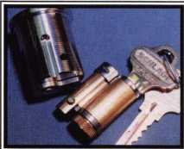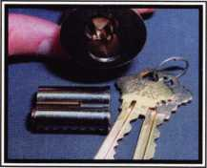

This is the SFIC (small  
format interchangeable  
core) which is best  
described as a duplicate of  
the Best system. They are  
totally interchangeable.

I have found the best way  
to pick these cylinders is to  
pin the cylinder and once  
it moves slightly, insert the  
homemade shim and con-  
tinue the rotation. There

is enough play in the check pin to allow this in most  
cases. Those cases where it will not work simply  
insert the shim first and then do your picking work  
around the shim.

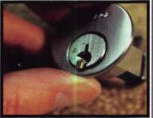

Here we see the check pin with its spring and a shim made from a key blank

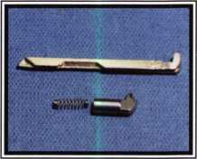

This photo shows a six-  
pin Everest mortise cylin-  
der. The cross section  
shows the springs of the  
six chambers and the  
check pin. The check pin  
falls between the 5th and  
6th pin chambers.

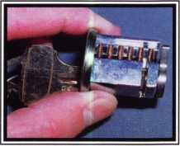

Compliments of Schlage

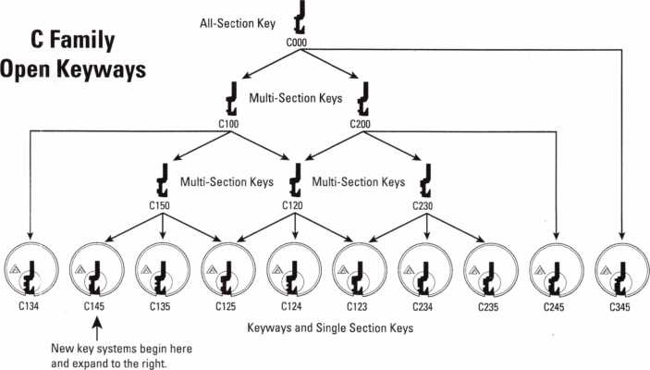

*Keynotes*

March 2001

RINGING BACK THE LOYALTY

The Everest key blank is made from a tough nickel silver material and is 15 percent thicker than the Classic blanks. This extra thickness helps to keep the blank from bending or breaking easily and it also makes it wear longer. The new bow of the blank is 25 percent larger than the Classic bow. This will help those customers who have difficulty in handling a key. Several of my arthritic customers are appreciating the difference.

So **Much More**

Since November 2000, Schlage has been using the “045” keyway as the default keyway for new key systems that are brought about through the factory. Anytime there is new construction that specifies a new Schlage system for commercial applications that does not require high security, it will be delivered on the “045” keyway. Prior to November, it was probably done on the “023” keyway. Now remember that I am saying commercial applications here. The Everest is not found as a default, or, for that matter, any application for residential. You as a locksmith can install the Everest cylinders taking the place of the Classic system found in residential situations. If you are doing Everest into a residential concern, know that Schlage has just introduced a new Grade 2 deadbolt numbered BC100. This bolt replaces the B100 and will be available in the key-in-knob cylinders (Classic, Everest, and Primus), full size IC cylinders, as well as the SFIC cylinders. Schlage is working for total utility and versatility within its entire product line structure.

I would like to make a suggestion here. If you have not yet worked with Everest and want more information, then order the poster and manuals in this article’s sidebar. When the materials arrive, take one evening to read and think about the opportunities available. The next day take an Everest cylinder and begin to play with it. You’ll be surprised what all it can do!

One of my great concerns was with inventory. Inventory deals with money. Money that is

tied up and possibly not working for you to make you more money is a sin. Schlage is helping. They offer a bulk package concept that is very important to us. The Bulk Pack Cylinders come in packs of 10 sub-assembled cylinders. They cost 20 percent less than buying a fully assembled cylinder. The subassemblies consist of preloaded cylinder housings with the springs and top pins. There is also a cylinder plug with a retainer and a choice of five tailpieces for the different appli­cations. (The tailpieces would interchange with the Classic cylinders.) The Bulk Pack Cylinders are available in key-in-knob, full size interchangeable core, mortise, and rim. A Bulk Pack Cylinder can be fitted to a Schlage “A,” “AL,” “H” or “D” knob, or a “D” Leverset series lock set. Quality, versatility, quantity reduction, and cost reductions are always appreciated when it concerns inventory!

Everest provides the needs that I have and it will give me the customer loyalty that I remember from the older days of my lock- smithing career. Every locksmith should know just how easy it is to upgrade your services to your customer and of all of the benefits that are available with the Everest system. Schlage is rebuilding market share for itself while keeping the locksmith’s needs alive and growing.



The Schlage Commercial Factory located in Security, Colorado.

*SPEEDYPLK®*

THE AUTOMATIC  
KEY IDENTIFICATION  
SYSTEM

* Preprogrammed database with full side view
* Automatic inventory control and reorder program
* Create your own database(s) to match your keyboard
* Hire inexperienced personnel without training

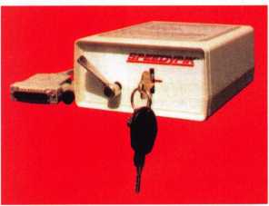

THE AUTOMATIC  
KEY DECODER SYSTEM

* Eliminates measuring each cut in a key
* Eliminates looking in pinning charts
* Portable, hand-held, battery-oper­ated
* Connects to your computer (serial port)
* Complete scan & readout in seconds

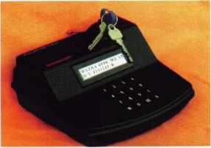

Phone: 617-567-1111  
Fax: 617-277-7777

E-Mail: SPEEDYPIK @  
AOL.COM

[www.SPEEDYPIK.com](http://www.SPEEDYPIK.com)

March 2001

Keynotes 21

***ILCO/UNICAN***



By Sal Dulcamara, CML

Series Programmable Pushbutton Lock

■

*Keynotes*

W

ith all the lock and security  
related companies that have  
been acquired by ILCO in  
recent years, it came as a sur-

prise to many of us in the security industry  
when ILCO was recently put up for sale. Not  
a great deal of time passed between the  
announcement of availability to the announce-  
ment of a buyer. It appears that the European  
company KABA will be the new owner of the  
ILCO/Unican empire.

Photograph 1 shows an ILCO/Unican 4000

series programmable  
pushbutton lock. It is a  
stand alone keyless elec-  
tronic lockset. Before

f I ILCO was recently sold,

ILCO had previously  
acquired the company

Mas Hamilton, which also manufactured a key-  
less electronic lockset called the PowerLever.  
The PowerLever comes in three models: 1000,  
2000 and 3000, but all three models are pow-  
ered by a small internal generator rather than  
batteries. Unless KABA has a similar product,

I believe that the 4000 series is ILCO's only battery powered stand alone electronic push­button lockset.

The 4000 series lock is a heavy duty grade 1, weather-resistant, vandal-resistant, keypad pro­grammable electronic lockset. It can be installed on outside doors where it will be exposed to the weather and elements. It will operate between the temperatures of minus 31 degrees Fahrenheit and plus 151 degrees Fahrenheit (equivalent to: minus 35 degrees centigrade and plus 66 degrees centigrade). The four AA alkaline batteries should last up to 80,000 openings, and there is a low battery warning. Available in three finishes (bright brass, satin brass and satin chrome), it uses a variety of interchangeable core types as the mechanical key bypass or override. Your 1C choices are: Best style (or Small Format Inter­changeable Core/ SFIC), Medeco/ASSA, Schlage (large format), and Yale.

This lockset is programmable at the keypad,

March 2001

but has no audit capability. It has an eight­digit master code, and three manager codes. There are 19 user access codes that can range from three to six digits. The unlock time is pro­grammable from 1 to 20 seconds. It is tamper resistant. After four successive wrong attempts, the lock will shut down. Shutdown time is pro­grammable from 1 to 15 minutes. There are more features, but many will be explained later in the article.

Drilling the Additional  
Mounting Holes

Like many of the other electronic locksets that  
are somewhat oversized compared to a typical  
mechanical commercial lockset, additional  
mounting holes are required for the 4000  
series lock. The standard commercial door  
prep will have a 2 1/8 inch diameter cross  
bore hole (set at a 2 3/4 inch backset) with an  
interconnecting 1 inch diameter edge bore  
hole. A paper template is included with the  
installation instructions, which will allow you to  
mark the various locations of the additional  
mounting holes to complete the installation.  
Separately, there are a number of different  
companies that make special installation jigs to  
make the job faster and more accurate. I  
recently discovered a fairly new company that  
makes some rather impres-

sive and clever installation

jigs. The company

called Locktools.com, and  
they have a jig specifically  
for the 4000 series lock.

Photograph 2 shows

the different parts that  
make up that installation  
jig. The back view of the  
jig, in photograph 3,  
shows a 2 1/8 inch diam-  
eter round locating block

that relates all the additional mounting holes to  
the existing 2 1/8 inch diameter cross bore  
hole. The spring loaded holding device (with  
handle) has a matching 2 1/8 inch diameter  
block to hook through the cross bore hole from

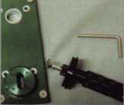

If ■ ■

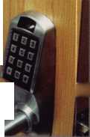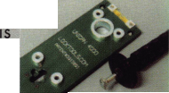

Series Programmable Pushbutton Lock

***ILCO/UNICAN***

ble. The signal cable connector (at end of ribbon cable) is passed through the newly drilled 1 inch diameter upper hole from the outside of the door to the Jk inside, as in photograph 8. The out-

H side housing assembly is pushed through

JH the 2 1/8 inch diameter cross bore hole

^ where it should interconnect with the

*****latch already installed. Make sure the * latch is properly aligned with retractor shoe of the housing assembly so that nothing binds or jams.

The 4000 series unit that I am assembling for this article uses an SFIC or Best style interchangeable core as the WmmWM mechanical override. At least for this I version, make sure that the override I plate pins in the outside lever handle

are positioned horizontally as in iHHB photograph 9. These pins will nor­mally go in the drilled holes at the back of a Best style I- Core. A core cannot be installed with the pins in this position, but that nBU is not the immediate purpose.

Photograph 10 shows the lower ■ half of the inside surface of the tS

inside housing assembly. The line I I

mark (to the left of my finger tip in HIT ttm photo 10) on the drive disk is aligned to the letter "L" (to the right of my finger tip in photo 10), which is positioned at about 3 o'clock on a clock face. At about 12 o'clock you will see the letter "R." These letters indicate left or right handing for the lock. Just rotating the drive disk to point to one letter or the other does not change the hand­ing. This lock is already left handed, but it will not func­tion properly if the line mark does not also point to "L." Paint marks on the square spindle should face up same as the flat surface of the override shaft.

»

The signal cable connector  
should be firmly inserted into the

4 socket found on the inside^housing

housing assembly should be positioned f / Jf

to interconnect with the outside housing

assembly, as in photograph 12. The JR

parts should assemble cleanly, and no m HL

excessive force should be used. The

excess cable length should be folded into the 1 inch hole,

making sure you do not pinch or cut the cable.

Keynotes

The "L" shaped stabilizer jig movement during the

the opposite side of the door.

pin minimizes

drilling process.

Photograph 4 shows  
view of the attached jig.

the inside (right  
side) is spring-  
loaded and a pro-

jected pin turns and locks onto the  
jig plate through the cross bore hole.

In photograph 5, spring pressure  
from the holder is all that keeps the

jig held snug onto the surface of the door. A built-in level

is at the top. One of the two small holes at the top of the  
jig would be drilled first, and then the stabilizer pin would  
be inserted into that hole to minimize movement of the jig  
while drilling the remaining holes. The holes should only  
be drilled halfway through the door, and then the jig  
should be removed and repositioned on the opposite side  
of the door to drill the rest of the way. Drilling all the way  
from one side will sometimes disfigure the door on the side  
where the drill tip protrudes. It will oftentimes not be as  
straight, also.

Installing the Lock

The additional mounting holes have  
been drilled in photograph 6, and

the latch has  
already been  
installed. The out-

side lock housing |

assembly is shown in photograph 7. \

The gasket material can be seen

around the outside edges on the back of the housing  
assembly. Besides the keypad and the workings below it  
is a gasket that helps to seal out the weather and the ele-  
ments. The ribbon cable stays within the outline of the gas-  
ket.

I am not going into specific details, but the 4000 series lock can be installed on doors ranging in thickness from 1 3/8 inches to 2 inches. It is factory set to a standard door thickness of 2 3/4 inches. Spacer washers and screws must be switched to adapt the unit for non-standard doors. Although this lock is left handed, the handing is field reversible. It is not something that you will typically accomplish in two or three minutes, but is possible if you have the need to do it. If you know (and order) the cor­rect handing in advance you'll save yourself time and trou-

m

March 2001

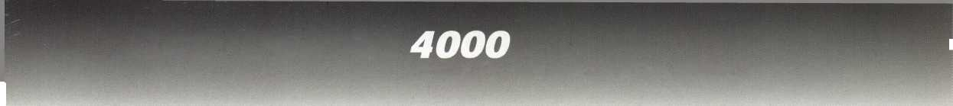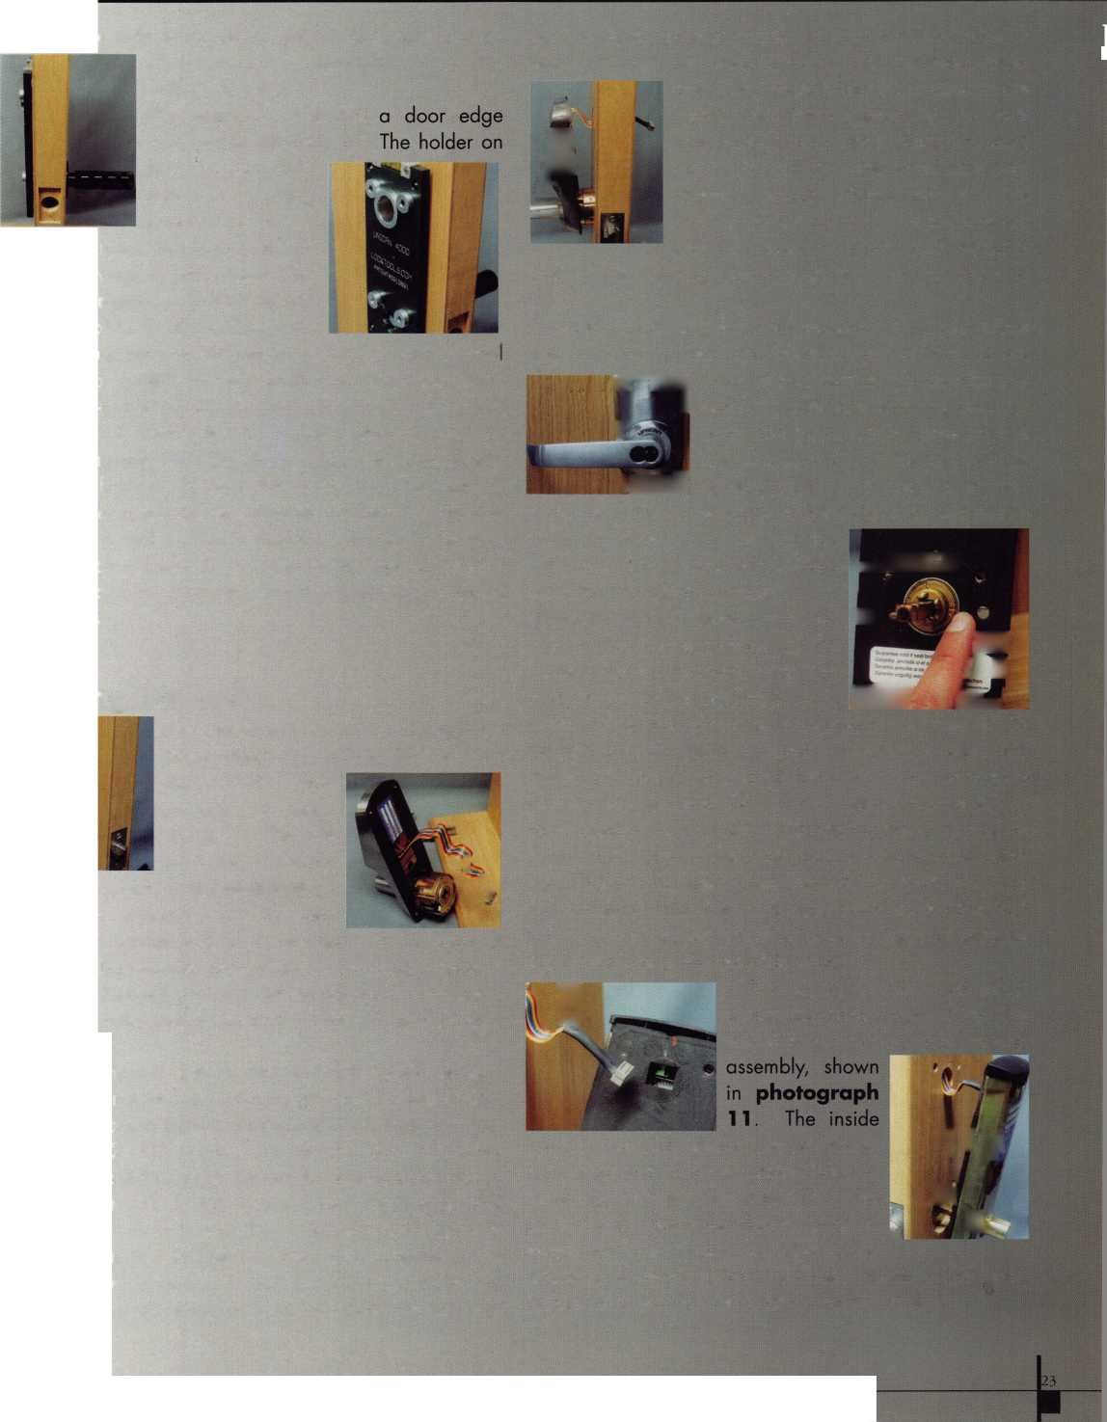

***ILCO/UNICAN*** *4000*



Series Programmable Pushbutton Lock

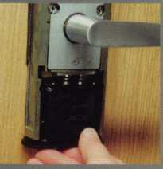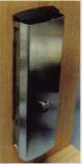

you can reposition the pins

rization

ager codes fusion, you procedures er code or

reen- | Wmm Jl

a correct user code should the

Hold the inside and outside lock hous­ings against the door while gently

inserting all four mounting screws, as in photograph 13. Tighten each screw a few turns to engage the threads. Then

T. —i M 8 tighten the bot-

tom screws almost completely, which  
should compress the inside gasket.

Test the movement of the outside  
lever handle while tightening the

bottom screws. The lever should move freely, as in photo-  
graph 14, as the latch is retracted.

Do not attempt to install and rotate the inside lever handle  
until the screws are tightened and the inside gasket is com-  
pletely compressed. There appears to be a disagreement  
between an older and newer version of the installation  
instructions. The old instructions suggest doing what the  
newer instructions tell you not to do. The modified instruc-

tions seem to be an insert slipped into a copy of the

instructions.

With a flat blade screwdriver,

for the 1-Core, as in photograph  
15, to disengage the override  
mechanism. The outside lever han-

dle should now turn

engaging the latch. Only by

gaging the clutch or entering a

outside lever operate the latch, inuw, wim me 5uew5 iiym-  
ened, you can temporarily attach the inside lever to the

shaft. Turn the handle, as in photograph 16, to see if the

latch retracts smoothly and easily. If  
it doesn't, there are suggested fixes

in the instruction book. If it does,  
you can proceed toward the rest of

the assembly.

First, verify that the

nism is not engaged and that turning the outside

not retract the latch. Then, tem-  
porarily attach the battery pack, as  
in photograph 17, to test the  
operation of the key pad. While  
the battery is in contact, enter 4000  
on the key pad. You should hear  
beeps and see LEDs flash, and the  
latch should retract when you turn

the outside lever handle. If that functions properly, you  
should be able to complete the lock assembly.

The inside lever that is temporarily attached should be

removed, so that the inside cover can be attached, as in photograph 18. The cover will snap into place and the inside lever can be reattached. This time, the lever will be held in place by a screw tight­ened by an Allen wrench included with the lock. The battery pack is slid in place

at the bottom of the inside unit and attached with screws as in photo­graph 19. With the installation completed, the 4000 series lock is ready to be programmed.

Programming the 4000 Series Lock

The 4000 Series lock has three levels of lock codes: Master, Manager (sub-Master), and User. The Master and Manag­er codes are authorization or control codes. They are not access codes, although they could be used to place the lock

passage mode, which would provide general accecvto

anyone without a key or access code number. These auth< •-

codes are used to program the 4000 series loci

The Master code has highest authorization, while the Ma

are more limited in scope. To minimize any co

to chart #1, as I review programming

and identify which can be done with a Manag

code or a Master code. The general steps are identifiec

in the chart, with the last column indicating if a Manage  
code has authorization for such programming.

Photograph 20 shows the key

pad of a 4000 series lock, with the

LED (Light Emitting Diode) display  
area just above the keypad. The  
green LED is lit in this picture. A rec

I LED also displays during certair  
I operations and circumstances. The

* red LED normally displays just to the

right of the spot where the green LED is now lit. A series o  
sounds and LED flashes accompany many operations anc  
programming procedures.

Code Lengths

The Master code is always eight digits. You can rearrange the digits in any way you choose, but it must always have eight digits. Similarly, the three Manager codes always have seven digits. Each Manager code controls a block o* six users. If all three Manager codes are used, you wil

*Keynotes*

March 2001

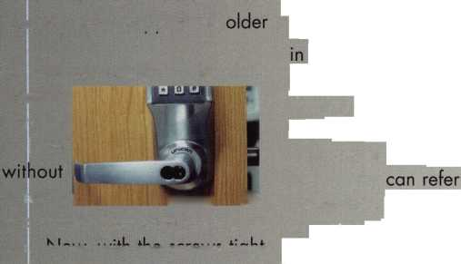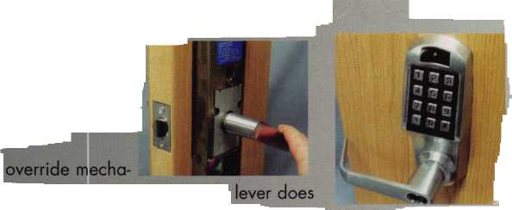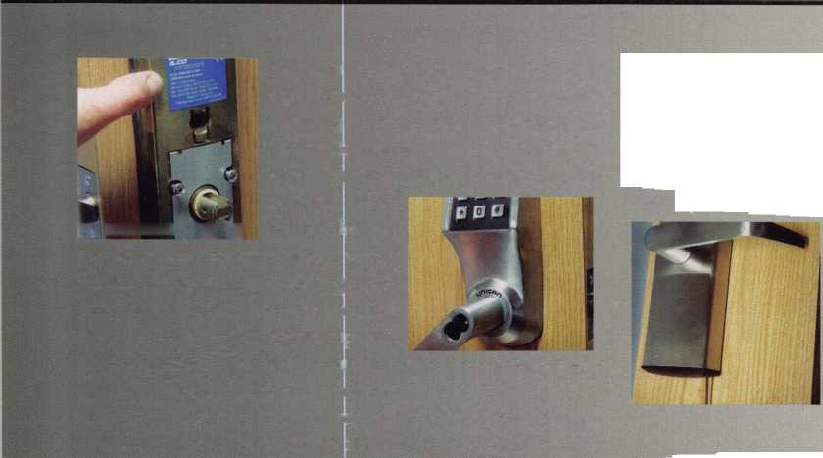

. V i-i'iS*

:''?;sc||^

account for 18 total

19th user code is

be affected byth©

codes. User a6t©l|f

to six d

has four digits/fhervi

of digits

codes available

unique codes. ||

Ten thousand  
and only one  
digits.

Choi**lHM**

When I testedth©

the access code  
default setting

12345678,

No other

grammed into a

have the same  
is to change it.

a telephone fa

its of a code qfc

typically used to

wrong command or

key can be used tG

don't press tfi^

ture of a progru ...  
the Master cod©6|

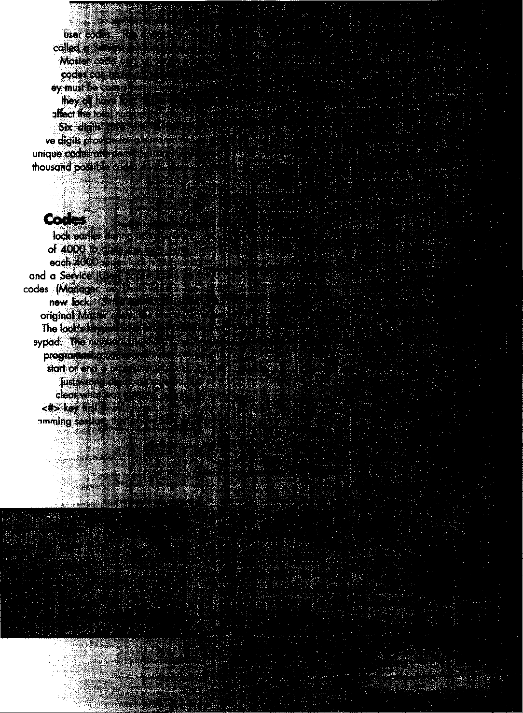

Series Programmable Pushbutton Lock

The same basic format applies for all the other programming procedures shown on chart #1. The last column of the chart will tell you if only the Master code can perform that function or if Manager codes can also. Individual user access codes within a partic­ular Manager group, can only be controlled by that specific Manager code or the Master code. The service access code can be affected or changed by the Master code or any Manager code. Certain lock functions on the chart can only be changed by the Master code, such as unlock time and tam­per shutdown time. It is a smart idea to write down codes before programming them into the lock.

A chart in the operations manual, shown as Chart #2 in this article, is designed to keep track of lock codes and users. Failure to write down this information might result in the loss of the various codes, but especially the Master code. Fortunately, there is a reset switch in this lock, to reset the lock to factory default settings. Not all electronic locks have this feature. You do, however, lose all other specially programmed changes, which will have to be repro­grammed later

To fully appreciate all the operations and functions, you will need to read the Opera­tions Manual. With a little bit of practice, the 4000 series lock seems to be fairly sim­ple to operate. With a decent quality instal­lation jig, the installation should also be a relatively simple task.

For more information on the ILCO/ Unican 4000 Series locks, contact your locksmith wholesaler that sells ILCO products*,* or contact ILCO at: 800/849-8324. The installation jig is one of many (for other locksetsj called TimeSaver jigs. They are available from: Locktools.com, 60 N. Winchester Blvd. #4, Santa Clara, CA 95050. Phone: 408/979-0337. You can find them on the web, where you might expect, at: [www.lock- tools.com](http://www.lock-tools.com)

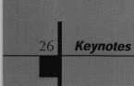

4000 Series Lock Command Codes

(Primary + Secondary number)

|  |  |  |  |  |
| --- | --- | --- | --- | --- |
| Command Code Name | Primary  Sub-command | Secondary Sub-command &  Description | | Manager  Authorized? |
| Disable code temporarily | 0 | 00 | All codes (except Master) | No |
| (lockout) |  | 01,02,03 | Manager authorization codes | No |
|  |  | 10,20,30 | Group 1, 2, or 3 access codes | Yes |
|  |  | 11 to 16 | Group 1 User access codes | Yes |
|  |  | 21 to 26 | Group 2 User access codes | Yes |
|  |  | 31 to 36 | Group 3 User access codes | Yes |
|  |  | 77 | Service access code | Yes |
| Re-activate (previously | 1 | 00 | All codes | No |
| disabled) code |  | 01,02,03 | Manager authorization codes | No |
|  |  | 10,20,30 | Group 1,2, or 3 access codes | Yes |
|  |  | 11 to 16 | Group 1 User access codes | Yes |
|  |  | 21 to 26 | Group 2 User access codes | Yes |
|  |  | 31 to 36 | Group 3 User access codes | Yes |
|  |  | 77 | Service access code | Yes |
| Add or change code | 2 | 99 | Master authorization codes | No |
|  |  | 01,02,03 | Manager authorization codes | No |
|  |  | 11 to 16 | Group 1 User access codes | Yes |
|  |  | 21 to 26 | Group 2 User access codes | Yes |
|  |  | 31 to 36 | Group 3 User access codes | Yes |
|  |  | 77 | Service access code | Yes |
| Delete code permanently | 3 | 00 | All codes (except Master) | No |
|  |  | 01,02,03 | Manager authorization codes | No |
|  |  | 10,20,30 | Group 1, 2, or 3 access codes | Yes |
|  |  | 11 to 16 | Group 1 User access codes | Yes |
|  |  | 21 to 26 | Group 2 User access codes | Yes |
|  |  | 31 to 36 | Group 3 User access codes | Yes |
|  |  | 77 | Service access code | Yes |
| Passage mode | 4 | 00: | Disable | Yes |
|  |  | 01: | Enable | Yes |
| Remote unlock |  | 90: | Disable | Yes |
|  |  | 91: | Enable | Yes |
| Set unlock time | 5 | 01 to 20: | 1 to 20 seconds | No |
| Set tamper shutdown time | 6 | 01 to 15: | 1 to 15 minutes | No |
| Buzzer sound | 7 | 00 | Off | No |
|  |  | 01 | Soft | No |
|  |  | 02 | Loud | No |
| Configuration setup | 8 | 00 | Commercial | No |
|  |  | 01 | Residential | No |
|  |  | 02 | Handicapped | No |

Code Record Log Sheet for the 4000 Series Lock

Serial Number: Location:

|  |  |  |
| --- | --- | --- |
| Name | Authority | Authorization Code |
|  | Master |  |
|  | Group 1 Manager |  |
|  | Group 2 Manager |  |
|  | Group 3 Manager |  |

|  |  |  |  |
| --- | --- | --- | --- |
| Name | Group # | User # | Access Code |
|  | 1 | 1 |  |
|  | 1 | 2 |  |
|  | 1 | 3 |  |
|  | 1 4 | |  |
|  | 1 | 5 |  |
|  | 1 | 6 |  |
|  | 2 | 1 |  |
|  | 2 | 2 |  |
|  | 2 | 3 |  |
|  | 2 | 4 |  |
|  | 2 | 5 |  |
|  | 2 | 6 |  |
|  | 3 | 1 |  |
|  | 3 | 2 |  |
|  | 3 | 3 |  |
|  | 3 | 4 |  |
|  | 3 | 5 |  |
|  | 3 | 6 |  |
|  | Service User | |  |

|  |  |
| --- | --- |
| | Operational Parameters | Current Setting |
| , Passage mode | □ Disabled □ Enabled |
| Remote unlock | □ Disabled □ Enabled |
| Unlock time | Seconds (1 to 20) |
| Tamper shutdown time | Minutes (1 to 15) |
| Buzzer sound | □ Off □ Soft □ Loud |
| J Configuration | □ Commercial □ Residential □ Handicapped |

March 2001

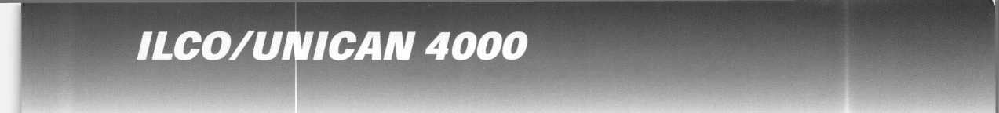

Associated Locksmiths of America

Member Name Number of

Sponsorships

Kwok-kei Leung Toshihiro Asano Henry W Raymond Yuriko Yanai Mary S Ohmit, CPL Charles C Robertson, CML Jack Hobin, CPL Wilbam B Neff, CML Salvatore J Dulcamaro, CML Myeong-Rae Cho Dana L Bamum, CML Barry K Leas, CRL Danny W Rudd, CPL Larry A Warnick, CML Jeanne G Lodge, CML C Allan Halverson Anthony J Ramunno, CML, CPS James M Watt, CML, CPS Jeffrey S Nunberg, CML, CMST J Thomas Hood, CML Jim Wilbams, CRL Lawrence F Smith Jr., CML James H Glazier Sr., CML Robert H Stafford, CPL Wilbam Lee John C Elliott Jr., CML Jerome L Cohen, CML Peter K Gauthier, CPL, CPS Robert F Carrob, CPL Robert D DeWeese, CML Marian M Swann, CRL Diana R Barnum, CRL Elvis D Hammerschmidt, CPL James J Cawby, CML, CPS Eugene R Altobeba Sr John L Shandy, CML Hans Mejlshede, CML John S Dorsey, CML D Michael Lee Sr., CPL James E Fowler Sr., CML David C Harris, CML Phffip A Rovenolt, CPL Peter R HaU

Thomas G Vandersteen, CML, CPS

Wilbam P Grant, CRL

Keizo Takahashi, CRL

Evelyn V Wersonick, CML, CPS

Joseph P Ferrero, CML

Gary F Teams, CPL

Robert W Duman Sr., CML

Michael D Robinson, CRL

Brian J Reetz

Maurice Benson

Walter W Lascar, RL

Wilbam JMcElheney, CML

Russeb P Fuber, CRL

Michael B Groves

Daniel L Landry Jr.

Robert C Rodocker, CRL James E Gruber, CRL Michael E Jordan Jr., CML Jon B Griswold, CML James T Brickler, CRL Man S Seo

Joseph C Fuber, CPL, CMST Leonard J Passarebo, CPL Frank D Hartung, CML Joseph W Whitaker, CPL Robin A Horsley Paul M Souber Donald H Shiles, RL Richard C Sievers Joe J Lee, CRL Ernest W Wright Rolando Bouza Raymond C Lusk, CML John F Engel, CRL Eric F Veal

Basil W Shannon, CPL Wilbam J Wickward, CML Calvin G Harris, CML Herbert C Dusenberry, CML, CPS Timothy K Chow Dale L Knowles, CPL Thomas J Demont, CML, AHC Alvin N Minor Gene Eldridge, CPL Ronald P Riggins, CML Lester S Brodsky Larry L Votaw, CML Thomas R Smith, CPL Richard T Johnson, CPL Dale V Crosby, CPL James V Hawley, CRL

Brightest

And The

Best.

How can I join the President's Club?

You can earn membership in this prestigious dub by recruiting just 10 new members for ALOA.

*Any ALOA member may participate.

What do I get?

When you recruit 10 members, you receive a handsome blue blazer with a President's Club crest. For each additional five members you recruit, you receive a lapel pin with gold-filled numbers, indicating your recruiting successes.

You also get the satisfaction of knowing that you are helping your association, helping your industry grow, and you are helping fellow locksmiths achieve success.

How do I get started?

Contact the ALOA office for a supply of applications (800) 532-AL0A or FAX (214) 827-1810. One President's Club credit is awarded for each new applicant. Credit is awarded only after the membership application is approved. However, the credit will apply for the period in which the application is received. Failure to identify yourself as the sponsor on the application form at the time it is submitted to ALOA for processing will forfeit any credit.

*AL0A Board of Directors not eligible for membership in the President's Club.

March 2001

Keynotes



intf* . Iteaews^

GardLok 300 Series Electronic Push Button Lock from SAFLOK by Sal Dulcamara, CML

U /CJO



*rdLok*

if

: ILmm

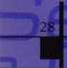

MIP %HMr

■

There are quite a few different brands of electronic push  
button locks for your more typical commercial doors, but  
you have to search a bit to find one for a narrow stile  
aluminum door. If you’ve been looking for such a lock,  
your search may be over. Photograph 1 shows the  
GardLok 300 series electronic lock for narrow stile

aluminum doors. There are actually  
two separate units in the photo, one  
from a back view and the other from  
an angled front view. The lock has a  
ten digit key pad and is powered by  
an ordinary 9 volt battery. This  
particular version is designed to  
work in conjunction with (and  
replace the keyed cylinder) an  
Adams Rite MS 1850 series swing

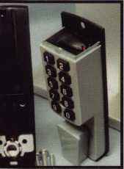

: lock, or otherwise compatible locks of other brands. It has one Master code and can have up to nine individual user codes. Besides programming, the Master code can act as a tenth user code. The GardLok has a low battery warning, and installs fairly quickly.

Installing the GardLok

The installation instructions are found on the lock box,

and are kind of short and  
sweet. A cellophane (or  
plastic) template is used to  
mark the holes. There are  
actually two separate  
templates, one for the inside  
and one for the outside.

Photograph 2 shows the  
general look with the stick-on  
template, although the full-size

template tends to slightly wrap around the door edge.  
The part shown is the part that remains if the lock is  
installed over the template and the rest is pulled off after  
lock assembly. My personal opinion is that they  
shouldn’t rely on the accuracy of that hole. I’ve experi-  
enced many a narrow stile aluminum door where the  
mortise cylinder was not necessarily concentric with the  
hole in the door. It might be smarter to design a template

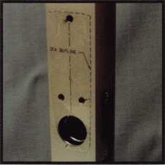

around an installed mortise cylinder to make sure everything lines up properly.

If your cylinder opening (for the Adams Rite lock) matches the circular opening in the aluminum door fairly closely, the plastic templates should work fine. If the holes are not quite in alignment, I’d suggest you either eyeball it through the cylinder opening for the lock and adjust as necessary or rough position the template and thread a mortise cylinder into the opening a few turns to locate the hole properly. Then you should be able to rub the plastic template to stick to the door surface. The three quarter-inch holes should be drilled from both inside and outside to make sure everything lines up straight.

A type of actuating disk is

It

■ shown in photograph 3.

looks like the back of a mortise

cylinder.

cylinder with an Adams Rite  
style cam. The opposite side

with the GardLok

device. It does not thread in,  
but does lock into place with  
the set screw that normally  
retains a keyed mortise

Photograph 4 shows a part called the mortise

positioning block that would  
normally fit within the door. I  
have it placed against the  
surface of the GardLok to show  
how the holes match up. The  
threaded hole on the side would  
mate with the attaching screw  
that replaces the top screw  
holding the Adams Rite lock  
attached to the aluminum door.

Presumably, this keeps the hole positions aligned  
properly.

With the mortise positioning  
block and actuating disk installed,  
photograph 5 shows how the mating  
piece on the GardLok matches and  
where the three threaded mounting  
holes on the lock match the holes in the  
door. If you left the plastic template on  
the door surface, you could position the  
GardLok along the outline and press it

*m«sJr*

l

: %

j»—% J*

wdt WMHUM TM

*K*

*m*

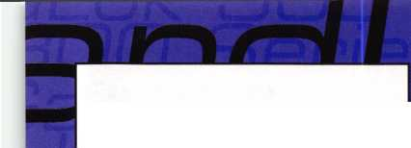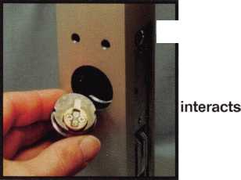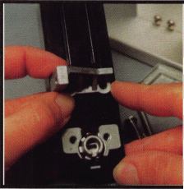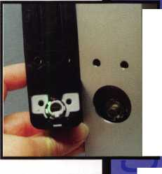

against the outside door surface. Otherwise, you would have to just approximate the position and let the screws coming from the inside of the door locate the lock.

photograph 6, the two lower screws are

tightened to fasten the GardLok to the  
door. The third (top) screw is  
designed to secure the battery cover.  
It is positioned and ready to install in  
photograph 7. With the cover

[separately  
[secured, the

I battery can be

(changed  
"without taking

the lock off the door. Merely  
loosen the top screw to remove  
the top cover. After replacing a  
bad battery, you can just replace  
the cover and reattach it by

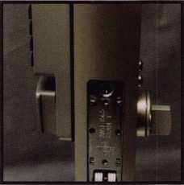

tightening the one screw.

The lock is completely assembled in photograph 8. To test the smooth operation of the lock, you can enter the default master code on the keypad. All user PIN codes are six digits in length, and the default Master code is: 111111. If the turn piece turns roughly, you may have to make some repositioning adjustments.

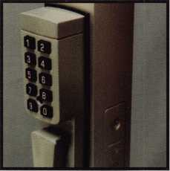

If it works well, you should be ready to program the lock.

Programming the GardLok

Since all GardLoks have the same factory set Master code, the first thing you will want to do is change that code. Even if someone didn’t know what the factory default code was, the combination 111111 is probably the most obvious random guess.

I mentioned earlier that there are nine possible individual user codes and the Master code. When storing or changing a code, you must have a way of accessing the particular code. The 10 keys on the key pad each identify a user code ID location or the Master code. Position 1 (or the #1 key) is used to identify (or for changing) the Master code. Positions 2 through 0

identify the nine individual user codes. When program­ming, a specific key will identify a specific user code. Programming (or reprogramming) the Master or user codes follows mostly the same procedure, except that only the Master code can be used to reprogram other codes. The basic programming procedure goes as follows:

1.

Hold down the zero key until the lock beeps twice.

2.

Enter the Master Code.

3.

Enter the position of the code you want to program or change. That will be from

2 to 9 if a user code, or 1 if the Master Code. The lock will beep twice.

4.

Enter the six-digit code twice. The lock will beep twice after the first time and give a long beep after the same six digit code is repeated a second time.

That completes the process. You have either added a new code or changed an old one. Only the Master Code can change other user codes or itself. User codes can only unlock the lock.

It is also possible to disable a code without changing it. This process, in effect, turns off access by one of the users without changing the code. The code can be (re)enabled later, without having to reprogram the whole six digit code. The Master Code cannot be disabled — only changed. The process to Enable or Disable a user code is as follows:

1.

Hold down the zero key until the lock beeps twice.

2.

3.

Enter the Master Code.

Enter the position code of the code you want to disable (2 though 0).

4.

Push the #2 Key and hold it until the lock beeps twice. The User Code is now disabled.

A disabled code can be enabled by repeating the same process as above. The programming steps are

**JfLOK**

inn

*idi*

' iMpr

O _

I i #

J » 9

**-»DP**

ansi

—

#**9

□ n/il

*^Ch2001*

} **L**

**If**

*i L\**

*Keynotes*

129

w

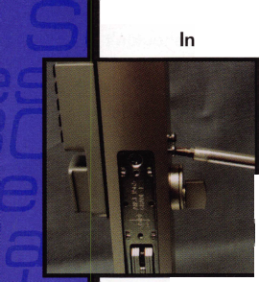

identical; it just reverses the condition. When done, an enabled code becomes disabled, and a disabled code becomes enabled.

After six unauthorized codes or wrong guesses, the lock will enter a “time-out” mode (shut down) for one minute and fifteen seconds. This reduces the chance of someone guessing a correct user code to open the lock.

Low Battery Warning

A low battery condition is revealed when a Master or User Code must be entered twice and the lock beeps eight times rapidly. This warning condition will occur for only twenty openings. After that, either code will have to be entered three times before the lock will open. If you (the customer) ignore the low battery warnings too long, you will end up with a lockout condition. If there is no other point of entry beside the door with the GardLok, you may need to find a way through the lock. If you contact SAFLOK’s customer service line (800/523-9605), you may get a suggested procedure to accomplish the task. Similarly, if the customer loses or forgets the Master Code, you may need to contact customer service.

H

Just in case that isn’t a good option for you, we

will go inside one of the GardLok units to consider some

other options. Photograph 9  
shows the inside with the back cover  
removed and the battery pulled out.  
The circuit board can be seen in the  
space evacuated by the 9-volt  
battery. Below that is a solenoid,

which is the key to the  
unlocking of the unit. A  
much closer view of that  
portion of the lock can be

seen in photograph 10. The roundish piece  
at the bottom is moved by the operation of the  
thumb piece of the lock. A slot in that piece is  
engaged by the solenoid. When a correct  
code is entered, the locking piece of the  
solenoid is pulled up to allow free motion to  
the thumb piece.

It is my impression that the least destructive way to overcome a dead battery is to remove the screw at the bottom of the thumb piece (not shown), and with the

thumb piece removed, drill a small access hole through that roundish part (from the outside) to gain access to the bottom of the solenoid. Using a small probe, the solenoid should be possible to push up in order to open the lock. If that part is separately available, it probably shouldn’t be too difficult to replace.

If you conceive of a practical drilling procedure, you may want to experiment and practice a little before trying it on a mounted lock, but in less than ideal circum­stances you may have to do it out in the field as your first attempt.

Other Product Variations

The 300 Series GardLok is available in an aluminum and duranodic finish. The model E301 is similar to the 300 series, except that it is designed for the Adams Rite MS4710 latch type lock for narrow stile aluminum doors. There are a few subtle differences, but it is very similar. It comes in the same finishes. For standard type doors, there are the model E311 (latch type) and model E312 (deadbolt) that interact with Weiser style residential door hardware. The electronic keypad unit is essentially the same with different accessories. The programming process is exactly the same for all four versions of the lock. For additional information on the GardLok product line, contact: Computerized Security Systems, 1020 West17th Street, Costa Mesa, CA 92627. Phone: 949/722-5400, Toll Free: 800/523-9605, FAX: 949/722-7017. Or find them online at: SAFLOK.com

—



ALOA Video Library

Order Form

Policies of the ALOA Video Tape Library and procedure for ordering videos:

1. Videos are loaned to ALOA members, chapters and local associations for a period of one (1) week. All tapes

are VHS format. Notice: All video tapes are protected under the US copyright laws and may not be duplicated.

1. Only one tape per order is allowed unless prior arrangements have been made with the ALOA office.
2. Charges: $5.00 per tape for shipping and handling.

$10.00 per day late charge. Late charges are assessed for tapes more than 2 days late.

$100.00 per tape for loss or damage.

1. Payment for shipping and handling must accompany the order, except for faxed orders. Any additional charges will be billed to the borrower.
2. A credit card account number must be included on the video order form as a deposit. If the video is not returned, your credit card will be billed for late charges or for loss/damages.

Credit card # Expiration date

1. It is the responsibility of the borrower to insure each tape for the $100 against loss or damages when returning videos to the ALOA Library.
2. Failure to remit shipping and handling, late, or any other charges may result in suspension of borrowing privileges.
3. To order a video, indicate 1st, 2nd, and 3rd choices on this form, fill out the bottom portion completely, and

mail the entire form to: ALOA Video Department, 3003 Live Oak St., Dallas, Tx 75204

1. Orders may also be faxed to (214) 827-1810.

* except for faxed orders and orders from outside the US

Q 99 Rim Device Installation Q Advanced Door Panel Servicing Volume 1

* Air Bag Steering Columns Volume 1

o Air Bag Steering Columns Volume 2

* Auto Lock Servicing Update #1
* Automatic Dialer
* Basic Door Panel Servicing
* Basic Locksmithing, Volume 1
* Beretta & Corsica: Opening and Fitting Keys
* Business Locks and Locking Devices

Q Car Opening Update #1

* Car Opening Update #2
* Car Opening Update #3
* Car Opening Update #4 Q Car Opening Update #5
* Car Opening Update #6
* Car Opening Update #7
* Chrysler Double-Bitted Locks
* Chrysler Pin Tumbler Locks
* Chrysler Steering Columns Q Detention Locks

Q The Door to Business Security

□

□

□

□

□

□

□

□

□

□

O

□

□

□

□

□

a

□

□

□

□

□

□

□

The Door to Home Security Filing for Dollars Ford Locks

Ford Steering Columns GM Locks

GM Steering Columns Home Security Alarms Home Security Survey Import Models, Volume 1 Import Models, Volume 2 Impressioning GM/Ford Sidebar Locks Labeled Fire Door Lock Mortiser

Mastering the Art of Impressioning

On the Home Front

Padlocks

Pinning KABA

Plugging for Profit

Precision Key Machines

Residential Locks and Locking Devices

Residential Magnetic Contact Applications

Robbery Prevention Techniques

S&G 6120 Series

S&G Combination Lock Fundamentals for the R6730-TOR (5/90)

S&G Commercial Products (2/90)

Q S&G Government Products (8/89)

* S&G Integrating High Security with Life Safety

S&G Locking Mechanisms (6/89)

**[~j** S&G R6730-TOR Combination Lock n (8/90)

S&G Scrambler Servicing

* Safe Deposit Locks, Volume 1
* Safe Deposit Locks, Volume 2
* Safe Deposit Locks, Volume 3 Q Servicing the Honda and Acura

Q Servicing the Toyota & Similar Locks Q Shock and Moisture Sensors:

High Security Risks  
Q Somebody's Watching

* Standard Steel Door Frames Q Standard Steel Doors

d Thief on the Loose!

Commercial Glass Break Applications Q Toyota Split - Tumbler Locks: Use and Adjustment of Gemini Key

* V.A.T.S. Made Simple

Q What's Behind a Fire Door Test Label? Q Yale Door Closers

**1/96**

ALL INFORMATION MUST BE COMPLETE OR PROCESSING MAYBE DELAYED

ALOA Member #

Name

Address (No P.O. Box)

City

Enclosed is jj Check

Date Needed: **Phone #**

State .

Money Order

ZIP

for shipping & handling

March 2001

***Keynotes***

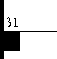

Area Convention and Visitors Association

***Keynotes***

***March 2001***

The

Best

of Baltimore

By: Claire L. Cohen, CML

THIS YEAR, THE ALOA 2001

Convention and Security Expo will be held at the Convention Center in downtown Baltimore, Maryland. This is the ideal location for a convention as well as a tourists dream. Don't miss out on some of the local attractions while you are there. Plan to spend a day or two before or after the convention discovering the "Best of Baltimore."

From the world-renowned Inner Harbor to historic Fort McHenry, Baltimore offers ALOA Convention attendees a great variety of attrac­tions. Many of the places of interest are just walking-distance away, so be sure to wear some comfortable walking shoes! Bring some comfort­able summer clothing, as histori­cally, the weather in July in Baltimore is warm and humid.

Nicknamed "Charm City" for its residents well-established concern for the quality of life, Baltimore was visited by 1 3 million people last ear. In addition to being rich with istory and culture, Baltimore is family-friendly, offering a multitude of attractions and activities for children and adults. Founded in 1729, Baltimore grew to be the third largest city in the U.S. by 1 860; today it's the 1 3th largest. Baltimore has a world port (ranking

5th among U.S. ports), government offices, significant medical and educational institutions and major tourist attractions.

Since its renovation in the late 1970s, millions of people have visited Baltimore's Inner Harbor— the focal point for downtown activities and attractions. Over the past 30 years, the Inner Harbor, Oriole Park at Camden Yards, the Maryland Science Center and the National Aquarium have transformed the city of Baltimore. Here visitors can ride the elevator 27 stories to the top of the World Observation Level and Museum in the World Trade Center, explore the inside of a World War II submarine at the Maritime Museum, and visit sharks, dolphins, sea turtles, and thousands of other aquatic animals at the National Aquarium.

Located on Pier 1, the center of Baltimore Inner Harbor, the USS Constellation (the last all sail warship built by the U.S. Navy), is open to the pubic as a museum. As the only Civil War era vessel still afloat, the ship invites guests to step back in time and explore the decks of history. The ship provides a spec tacular view of Baltimore's historic waterfront and illuminates the

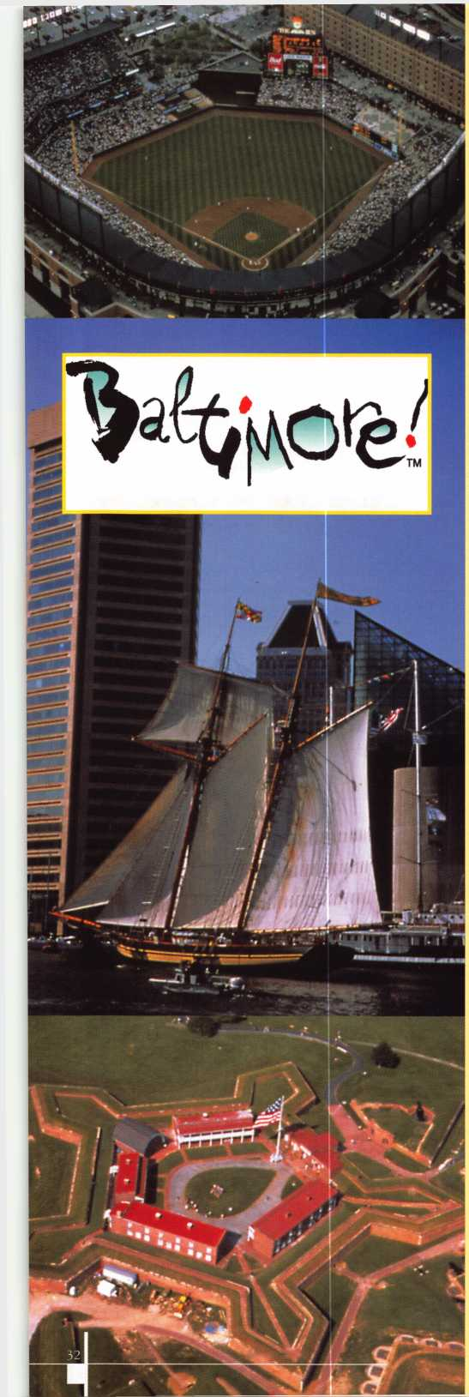

skyline at night. Interactive presenta­tions and demonstrations by the ship's crew give further insight into what it was like to sail on board a 19th century naval sailing ship.

Across the Harbor, the Maryland Science Center offers visitors three floors of hands-on exhibits and demon­strations, the Davis Planetarium, and IAAAX five-story theatre. Nearby, the kid- powered museum, Port Discovery, is where three floors of interactive fun await kids of all ages. At the Baltimore Maritime Museum, three ships tell an exciting story of American naval power and enterprise from the 1930s to the late 1980s. At the top of the World Observation Level, located in the World Trade Center is a panoramic view of Baltimore and beyond, with historical exhibits, special events and more. Not to be missed, the world-famous Baltimore

Aquarium features sharks, dolphins, rays, tropical fish and many other creatures in natural exhibits including a walk-though living rain forest. Just a short walk from the Baltimore Convention Center, located at the center of Baltimore's Inner Harbor, Harborplace is an urban market, packed with popular retail shopsoa place where you can walk, shop, eat, enjoy music and take in the beautiful harbor views after a day of classes.

Hop aboard a Water Taxi to get a quick overview Historic neighborhoods of Federal Hill, the maritime community of Fells Point, (the center of Baltimore's thriving shipbuilding industry in the 1 8th and 19h centuries), Little Italy (a fantastic place to dine) and fashionable Mount Vernon Place. Perhaps you may want to take one of the Baltimore Harbor cruises where you can sail the harbor area and dine on a climate-controlled boat.

**Oriole Park at Camden Yards**

is the home of the Baltimore Orioles. Nearby is the Babe Ruth

Birthplace & Oriole Museum

First opened to the public as the Babe Ruth Birthplace Shrine, the Museum has expanded over the past two decades to include the Baltimore Orioles and Maryland baseball.

Another popular site is Fort McHenry National Shrine and Monument. The original manuscript of the poem written by Francis Scott Key, "The Star-Spangled Banner" is on display at the Maryland Historical Society Museum. While there you will be close to PSINet Stadium, the home of the NFL's Baltimore Ravens.

Located within an easy walking distance of the Inner Harbor area is the B&O Railroad Museum. The

B&O Railroad Museum possess one of the oldest and most comprehensive railroad collections in the world. The museumis collection dates from the very first days of the B&O Railroad. Hundreds of models ranging from early patent and prototype models to modern commercial model railroad kits are on display.

At the Lexington Market, the

number of choices and wide variety of all types of foods will dazzle any tourist visiting Baltimore, including seafood from the Chesapeake Bay. Enjoy a multitude of prepared foods, including award-winning Maryland lump crab cakes and arrays of interna­tional dishes, available from 140 individual stalls.

Baltimore also has been a center of art, music, literature and culture for many years. It is home to the oldest music school in the U.S., the Peabody Conservatory of Music, as well as the Baltimore Symphony Orchestra, and the Baltimore Opera. The country's oldest museum building, the Peale Museum was built in Baltimore by painter Rembrandt Peale in 1 814. At the Walters Art

Gallery, rooms that remind you of an ancient castle with suits of armor for men and horses, an eight-store tapestry, Egyptian mummies and much more can be seen. Paintings by Picasso and Cezanne are among the many works of art at the Baltimore Museum of Art. Among Baltimoreis literary landmarks are the homes of Edgar Allan Poe and H. L Mencken

The Baltimore Zoo is only a 10- minute drive from downtown. Some of the Inner Harbor hotels have a Zoo Shuttle (primarily on weekends). The Baltimore Zoo houses more than 2,000 animals. Take a "safari" through Africa and experience hands-on adventures in the number one rated Children's Zoo.

While in the Baltimore region, sample traditional Chesapeake Bay cuisine. If seafood is not your preference, you'll find foods from around the world served "Baltimore style." From fine dining to a "roll-up-your sleeves” crab feast, Baltimore's restaurants offer something for all tastes.

Every day is a busy day in Baltimore, especially in the summer months when many people are on vacation. Baltimore is a great city from which to plan day trips. Within two hours by car are historic Annapolis, Washington, D. C., Pennsylvania Dutch Country, Hershey, Gettysburg and St. Maryls City.

Hope to see you there!

Editor's Note: For best possible travel rates, you should make reserva­tions as soon as possible. For recre­ational activities in Baltimore, it may be necessary to plan activities and purchase tickets in advance.

Keynotes L

March 2001



L

ast year, California passed a law that  
now requires vehicle manufacturers to  
disclose to service and parts providers

any information necessary to diagnose and  
repair or replace parts monitored by the on-  
board-diagnostic system (OBD). For all 1994  
and later model year vehicles which have  
OBD systems, this new law lays down spe-  
cific requirements which must be met to give  
access to the system and essential informa-  
tion regarding it to both parts and service  
providers. The full contents of all manuals,  
technical service bulletins (TSBs) and train-  
ing materials regarding emissions related  
material that is provided by the vehicle man-  
ufacturer to its franchised dealers must be  
furnished to parts and service providers as  
well. It must be provided by reasonable  
means, such as the Internet, and within a rea-  
sonable time after the model is introduced.  
This requirement is basically the same as fed-  
eral law. The vehicle manufacturers must  
make available for sale to all parts and service  
providers their proprietary enhanced diag-  
nostic tools, and provide the enhanced data  
streaminformation and bi-directional con-  
trols used in those tools in electronic format  
to equipment and tool companies so that  
they can be incorporated into generic diag-  
nostic tools. If a vehicle manufacturer uses  
reprogrammable chips, the same program-  
ming information provided to its franchised  
dealers must be provided to equipment and  
tool companies so that it can be incorporated  
into generic reprogramming tools. For 1996  
and later model years, a general description  
of the OBD system must be provided includ-  
ing: a general description of the operation of  
the monitor, including a description of the  
parameter being monitored; typical diagnos-

tic trouble codes associated with each moni­tor; a description of the typical enabling con­ditions for each monitor, including vehicle speed range, and minimum and maximum intake air and engine coolant temperature; a listing of each monitor sequence, execution frequency and typical duration; typical mal­function thresholds for each monitor; and typical OBD II parameters for specific vehi­cles that deviate from the norms. Manufac­turers are forbidden to use any access or recognition codes or encryption for the pur­pose of preventing an owner from using any emissions-related part, whether OE or after- market. Finally, manufacturers must provide to parts and service providers any informa­tion regarding initialization procedures relating to immobilizer circuits or other lockout devices if the information is neces­sary to repair or replace an emissions-related part.

However, a vehicle manufacturer can refuse to disclose any of the above information if it can prove to a California court that the data is a trade secret under the Uniform Trade Secrets Act. This exemption creates the pos­sibility of a loophole, but at least the burden is on the vehicle manufacturer to prove the alleged proprietary information actually is a trade secret. Moreover, even if a court finds that particular information is a trade secret, it can still require disclosure by the manufac­turer if disclosure is necessary to mitigate anticompetitive effects. The bill also allows a manufacturer to charge “fair, reasonable and nondiscriminatory compensation” for any information which the bill requires be dis­closed. Finally, it contains a system to com­pel disclosure if a manufacturer refuses to comply.

Check Out ALOA’S New On-line  
Legislative Tool!

Go to <http://www.aloa.org/news/legislation.cfm> and check out ALOA’s new on­line service that connects locksmiths to every member in their state legislature. It provides up-to-date information about key issues and gives users quick and easy access to state officials. You can contact legislators by cus­tomized or personalized e-mails, faxes or standard letters. It also conducts a 5 and 9-digit ZIP Code search so that you can identify your state and local offi­cials quickly. Check it out today!

LEGISLATIVE UPDATE

All bills that saw movement between 02/01/2001 and 03/01/2001

CALIFORNIA AB143

SUMMARY:

Requires locksmiths to maintain a bond of $2,500 for the benefit of persons dam­aged by a locksmith's failure to comply with specified duties and restrictions imposed under existing law.

STATUS:

01/25/2001 INTRODUCED.

Contact your legislator about  
this bill at <http://www.aloa.org/news/>  
legislation.cfm

ILLINOIS HB26

SUMMARY:

Provides that giving notice to the public by yellow page advertise­ment, through a sign at the facilities of the towing service, or by any other advertisement, that the towing service opens motor vehicle locks to enable a vehicle to be moved without towing does not constitute holding oneself out to the public as a locksmith if the adver­tisement does not use the word “lock­smith.”

STATUS:

01/10/2001 INTRODUCED

01/10/2001 To HOUSE Committee on RULES.

01/31/2001 SENT to House

Committee on Registration and Regulation

During the committee hearing, the com­mittee Chairman, another committee member and the allied Locksmiths for Illinois lobbyist spoke out against the bill. The bill has been tabled for future action.

Contact your legislator  
about this bill at  
<http://www.aloa.org/news/>  
legislation.cfm

Keynotes

March 2001

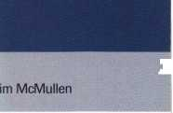

MISSISSIPPI HB148

SUMMARY:

Regulates the installation and service of burglar and intrusion alarm systems; defines certain terms; creates the Missis­sippi electronic security board of licensure and provide for it membership and administration; provides the powers of the board; provides licensing require­ments; provides exemptions from this act; provides for violations of this act; provides for uniformity; provides for its administra­tion.

STATUS:

01/02/2001 INTRODUCED.

01/03/2001 To HOUSE

Committee on JUDICIARY B

01/24/2001 FROM House Committee on Judiciary B: Do pass with substitute

01/30/2001 PASSED House

02/09/2001 SENT to Senate

Committee on Business and Finance.

ALOA has gotten the Mississippi Alarm Association to agree to strike the defini­tion and reference to "intrusion alarm" from the bill.

LAN -- Are You a Member?

As we continue to expand our resources and become more competitive in the leg­islative arena, we need the monetary resources to match our successes. You can help with as little as $14.95 to the Legislative Fund. This is only the mini­mum that we are asking, and encourage you to give more if you can. Those that contribute will be given a Legislative Action Network Member kit to use in their grass roots efforts. Members who donate $100 or more become Legislative Action Network Council members, and enjoy the following extra benefits: Direct input into the legislative strategic plan that guides all legislative activities; Dis­counts on ALOA bookstore items; 10 % rebate on all ACE classes; Complimentary Legislative Convention merchandise.

MasterLink Security Products

ROGER ALEXANDER-TUTTLE  
“...understanding the needs of locksmiths...”

Mortise/Rim/Knob Cylinders • Storefront Door Hardware  
Cabinet Locks • Chain • Key Blanks • Padlocks • Pins ...and more

Local: (954) 730.9669 • Toll Free: (877) 347.9669  
Fax: (954) 486.0575

e-mail: [masterlink@mindspring.com](mailto:masterlink@mindspring.com)

3863 NW 19th Street, Lauderdale Lakes, FL 33311

j

MLANJ 2001  
Annual Convention

March 29th thru April 2nd  
Somerset, New Jersey

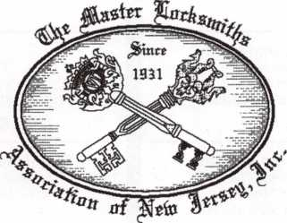

For More Information:

PO Box 2441

Morristown, NJ 07962-2441  
Phone 973-267-8884  
Fax 973-538-2248

Or visit our web site at

[www.MLANJ.org](http://www.MLANJ.org)

March 2001

Keynotes

Associate

Members

<E



**MANUFACTURERS**

A & **B** Safe Corp.

171 S. Delsea Dr.

Glassboro, NJ 08028  
(800) 253-1267; FAX (856) 863-1208

(0 g g

Abus Lock Company

3555 Holly Lane North  
Plymouth, MN 55447-0507  
(800) 352-2287; FAX (612) 509-9939

<£>

Adams Rite Manufacturing Co.

P.O. Box 1301  
LaPuente, CA 91749-1301  
(562) 699-0511; FAX (562) 699-5094

© g (0 g

Adesco Safe Manufacturing Co.

web: [www.adesco.com](http://www.adesco.com)  
email: [sales@adesco.com](mailto:sales@adesco.com)  
(800) 821 -6803; FAX (562) 408-6427

g

Adrian Steel Company

web: [www.adriansteel.com](http://www.adriansteel.com)  
Adrian, Ml 49221

(800) 677-2726; FAX (517) 265-5834

©

Alarm Lock Systems, Inc.

345 Bayview Ave.  
Amityville, NY 11701  
(800) ALA-LOCK; (516) 789-3383

•

Aiphone Intercom Systems

1700-130th Avenue, NE  
Bellevue, WA 98005  
(425) 455-0510; FAX (425) 455-0071

g g (0

American Lock Co.

3400 West Exchange Road  
Crete, IL 60417-2099  
(708) 534-2000; FAX (708) 534-0531

© ©

American Security Products (AMSEC)

11925 Pacific Ave.

Fontana, CA 92337-6963  
(800) 423-1881; FAX (909)685-9685

Baldwin Hardware Corp.

1841 E. Wyomissing Blvd., Box 15048  
Reading, PA 19612  
(610) 736-4012; FAX (610) 796-4493

g g

Buddy Products

1350 S. Leavitt Street  
Chicago, IL 60608

(800) 886-8688; FAX (312) 733-8536

g

BWD Automotive

900 Ravenwood Dr.

Selma, AL 36701

(334) 874-9001; FAX (334) 874-6011

g (g

Chicago Lock Company

10100 88th Ave.

Pleasant Prairie, Wl 53158-0069  
(800) 445-3204; FAX (414) 947-7178

©

Corbin Russwin Architectural Hardware

P.O. Box 25288  
Charlotte, NC 28229  
(800) 543-3658; FAX (800) 447-6714

g g g **(g**

Curtis Industries

6140 Parkland Blvd, Ste. 300  
Mayfield Heights, OH 44124-4103  
(800) 555-5397

g (g

DETEX

302 Detex Dr.

New Braunfels, TX 78130  
(800) 729-3839; FAX (830) 620-6711

g g g g g

DSC Group of Companies

3301 Langstaff Road  
Concord, Ontario, Canada  
(905) 760-3000 ext. 2200; FAX (905) 760-3040

g g g g (g

Don-Jo Manufacturing, Inc.

P.O. Box 929  
Sterling, AAA 01564  
(508)422-3377; FAX (508) 422-3467

g (g

Door Controls International

2362 Bishop Circle East  
Dexter, Ml 48130

(800)742-3634; FAX (800) 742-0410

Associate members of the Associated Locksmiths of America (ALOA) manufacture or distribute materials or equipment, or provide services, for the security industry. Many have donated money, services and equipment to ALOA in addition to their annual dues. Their support of ALOA projects enhances overall membership benefits and we encourage our members to patronize these firms. If you know of a potential candidate for associate mem­bership, please contact the ALOA Mem­bership staff at (800) 532-ALOA. Associ­ate

member dues are $500 per year and entitle the payor to use the ALOA logo, and receive selected discounts on ALOA products and services.

Legend

© Alarms: Personal, vehicle, electronic, fire, burglar, and exit @ Bank security equipment ® Automotive: Lockout equipment, key chains/rings

® Builders Hardware: Door closers, furniture/decorative hardware, view­ers, emergency exit devices ® Business/Technical & Educational: Books, reference guides, publications, computer software

© CCTV/Photo Imaging: Cameras, monitors, photo ID equipment, cables ® Electric/Electronic Security: Card access control and readers, surveil­lance, electric/magnetic locks and strikes, keypads

® Lock Devices: Auto locks, cylinders, emergency exit/entrance control, locks (various types), strikes ® Tools & Supplies: Key blanks, cut­ters, picks, rings/hooks, custom van/truck supplies ® Safes/Vaults © Other

ESP Lock Products, Inc.

375 Harvard Street  
Leominster, AAA 01453  
(978) 537-6121; FAX (978) 534-9109

© ©

Folger Adam Security, Inc.

16300 W. 103rd Street  
Lemont, IL 60439

(630) 739-3900; FAX (630) 739-6138

i0 0

Fort Lock Corp.

3000 N. River Rd.

River Grove, IL 60171  
(708) 456-1100; FAX (708) 456-9476

lg) g g g <g g

Grobet File Co. of America

750 Washington Ave.  
Carlstadt, NJ 07072  
(800) 962-7242; FAX (800) 243-2432

©

Keynotes

March 2001



|  |  |  |
| --- | --- | --- |
| H.E.S., Inc. | LAB Security | ROFU International Corp. |
| 2040 W. Quail Ave. | 700 Emmett St. | 2004-B 48th Ave.; Court E |
| Phoenix, AZ 85027 | Bristol, CT 06010 | Tacoma, WA 98424 |
| (602) 582-4626; FAX (602) 582-4641 | (800) 243-8242; FAX (203) 583-7838 | (800) 255-7638; FAX (253) 922-1728 |
| • • • | • | 9 9 9 |
| HPC, Inc. | LCN Closers (Division of Ingersol) | Rutherford Controls Inc. |
| 3999 N. 25th Avenue | 121 W. Railroad Ave. | 2697 International Pkwy, Bid 5 #100 |
| Schiller Park, IL 60176 | Princeton, IL 61356 | Virginia Beach, VA 23452 |
| (847) 671 -6280; FAX (847) 671 -6343 | (815) 875-3311; FAX (815) 875-3222 | (757) 427-1230; FAX (757) 427-9549 |
| • • • | • | • |
| HID Corporation | La Gard, Inc. | STRATTEC Security Corp. |
| 9292 Jeronimo Road | 3330 Kashiwa Street | 3333 W. Good Hope Rd. |
| Irvine, CA 92618 | Torrance, CA 90505 | Milwaukee, Wl 53209 |
| (949) 568-1600; FAX (949) 568-1680 | (310) 325-5670; FAX (310) 325-5615 | (414) 247-3333; FAX (414) 247-3329 |
| • • | • • • | • •• |
| High Tech Tools | Lucky Line Products | Sargent & Greenleaf, Inc. |
| 1400S.W. 1 Street | 7890 Dunbrook Rd. | P.O. Box 930 |
| Miami, FL 33135 | San Diego, CA 92126 | Nicholasville, KY 40340-0930 |
| (305) 649-7014; FAX (305) 541 -0074 | (619) 549-6699; FAX (619) 549-0949 | (606) 885-9411; FAX (606) 887-2057 |
| • • | • | 9 9 9 9 |
| Hongtai Lock Co. Ltd. | M.A.G. Engineering & Mfg. Inc. | Schlage Lock Co. |
| Jidong, Xiaolan Road, Xiolan | 15381 Assembly Lane | 1915 Jamboree Suite 165 |
| Zhongshan/Guangdong, China 528415 | Huntington Beach, CA 92649 | Colorado Springs, CO 80920 |
| (86) 137-238-1414; FAX (86) 208-793-3856 | (714) 891-5100; FAX (714) 892-6845 | (800) 847-1864; FAX (800) 452-0663 |
| • • m • | • • • | • • |
| llco Unican | MARKS USA | Schwab Corporation |
| 400 Jeffreys Road | 5300 New Horizons Blvd. | 110 Professional Court |
| Rocky Mount, NC 27804 | Amityville, NY 11701 | Lafayette, IN 47905 |
| (252) 446-3321; FAX (252) 446-4702 | (516) 225-5400; FAX (516) 225-6136 | (765) 447-9470; FAX (765) 447-8278 |
| ••••••• | • | • |
| In Out Systems, Inc. | MARRAY ENTERPRISES | Securitron Magnalock Corp. |
| 3650-B Matte Boulevard | 1128 Walsh Avenue | 550 Vista Blvd. |
| Brossard, Quebec J4Y-2Z2, Canada | Santa Clara, CA 95050 | Sparks, NV 89434 |
| (450) 444-5949; FAX (450) 444-4856 | (408) 970-0213; FAX (408) 970-8767 | (800) 624-5625; FAX (702) 355-5636 |
| 9 m | • 9 9 | • • |
| Intellikey | MUL-T-LOCK USA, Inc. | Security Door Controls |
| 551 S. Apolo Boulevard, Suite 204 | 300-1 Route 17 South Suite A | 3580 Willow Lane |
| Melbourne, Florida 32901 | Lodi, NJ 07644 | Westlake Village, CA 91361 |
| (800) 226-0703; FAX (407) 724-0811 | (800) 562-3511; FAX (973) 778-4007 | (805) 494-0622; FAX (800) 959-4732 |
|  | 9 9 9 | • |
| Jet Hardware Mfg. Co | Master Lock Company | Security Solutions |
| 800 Hinsdale Street | 2600 North 32nd Street | 1640 W. Hwy. 152 |
| Brooklyn, NY 11207 | Milwaukee, Wl 53211 | Mustang, OK 73064 |
| (718) 257-9600; FAX (718) 257-0973 | (414) 444-2800; FAX (414) 449-3114 | (405) 376-1600; FAX (405) 376-6870 |
|  | • • | • •• |
| KABA High Security Locks | Medeco Security Locks | Sentry Group |
| P.O. Box 490 | P.O. Box 3075 | 900 Linden Ave. |
| Southington, CT 06489 | Salem, VA 24153 | Rochester, NY 14625-2784 |
| (860) 621 -3601; FAX (860) 621 -9727 | (540)380-5000; FAX (540) 380-5010 | (716) 381 -4900; FAX (716) 381 -8559 |
| • | • • • | • |
| KEY-BAK; Div. of W. Coast Chain Mfg. Co. | Meilink Safe Company | Sully Tools Inc. |
| 4245 Pacific Privado | 111 Security Parkway | 3515 Nodding Pine Ct. |
| Ontario, CA 91761 | New Albany, IN 47150 | Fairfax, VA 22033 |
| (909) 923-7800; FAX (909) 923-0024 | (800) 634-5465; FAX (800) 896-6606 | (703) 689-3416; FAX (703) 787-0869 |
| • • • • | • | 9 9 9 |
| Knaack Manufacturing Co. | One Lock, One Key Inc. | Taymor Industries, Inc. |
| 420 E. Terra Cotta Ave. | 706 Hinsdale Dr | 1586 Zephyr Ave. |
| Crystal Lake, IL 60014 | Arlington, TX 76006 | Hayward, CA 94544 |
| (800) 456-7865; FAX (815) 459-9097 | (817) 860-1011; FAX (817) 275-6839 | (800) 388-9887; FAX (800) 288-8133 |
| • | • | • 9 |

March 2001

***Keynotes***

37

|  |  |  |
| --- | --- | --- |
| Trine Products Corporation  1430 Ferris Place  Bronx, NY 10461  (718) 829-4796; FAX (718) 792-9127  (g> (0 ® | ADI  263 Old Country Road  Melville, NY 11747 (516) 692-1000; FAX (516) 692-3457  ® © (0 | E. L. Reinhardt Co., Inc.  3250 Fanum Road  Vadnais Heights, MN 55110 (800) 328-1311; FAX (612) 481 -0166  ® ® (fj (g) (j) |
| Unelko Security Systems Ltd.  14641 N. 74th Street  Scottsdale, AZ 85260 (480) 991-7272; FAX (480) 483-7674 | Akron Hardware Consultants, Inc.  2579 South Arlington Road  Akron, OH 44319  (800) 321 -9602; FAX (800) 328-6070  (gj) (0 (gi | Ewert Wholesale Hardware  4709 W 120th St  Alsip II 60658  (800) 451 -0200; FAX (708) 597-0881  (g) (0 <£) (£} ^ |
| Videx, Inc.  1105 NE Circle Blvd.  Corvallis, OR 97330 (541) 758-0521; FAX (541) 752-5285  @ (0 ^ | American Security Distribution  4411 E. La Palma  Anaheim, CA 92807 (714) 996-0791; FAX (714) 579-3508  ® (ty (|J) (0 ® © | Fairway Supply, Inc.  2631 Lombardy Lane  Dallas, TX 75220  (214)350-0021; FAX (214) 352-4299  0 ® ® |
| Visonic, Inc.  10 Northwood Dr  Bloomfield, CT 06002 (800) 223-0020; FAX (860) 242-8094 | Andrews Wholesale Lock Supply  544 S. 9th St.  Lebanon, PA 17042-6608 (717) 272-7422; FAX (717) 274-8679  g}) | Foley-Belsaw Company  6301 Equitable Road  Kansas City, MO 64120 (800)821-3452; FAX (816) 483-5010  ^ <3^ © 4$ |
| W-Lok Corporation  675 East 16th Street, Suite 111  Holland, Ml 49423  (616) 355-4015; FAX (616) 355-4295  © | Boyle & Chase Inc.  P. O. Box 74  Accord, MA 02018-0074 (800) 325-2530; FAX (800) 205-3500  <3jl (0 ® | Fried Brothers, Inc.  467 N. 7th St.  Philadelphia, PA 19123 (800) 523-2924; FAX (800) 541 -3489 |
| Weiser Lock Company  6700 Weiser Lock Blvd.  Tucson, AZ 85746  (502) 741 -6338; FAX (520) 741 -6363  l|j} | Clark Security Products, Inc.  4775 Viewridge Ave.  San Diego, CA 92123-1641 (800) 854-2088; FAX (619) 974-5284 | HS&S Wholesale Distributors  12915 West 8 Mile Road  Detroit, Ml 48235  (800) 521 -2202; FAX (313) 342-7580  (|J) (|^ (0 @ <5 © |
| Wilson Bohannan Company  621 Buckeye Street  Marion, OH 43301-0504 (800) 382-3639; FAX (740) 383-1653  © | Cook's Building Specialties  2441 Menaul Blvd. NE; P.O. Box 37320 Albuquerque, NM 87176-7320 (505) 883-5701; FAX (505) 883-5704  ® ||J) (0 (0) (Jjt | Hans Johnsen Company  8901 Chancellor Row  Dallas, TX 75247  (214) 879-1550; FAX (214) 879-1530 |
| Yale Security Inc.  P.O. Box 25288  Charlotte, NC 28229-8010 (800) 438-1951; FAX (800) 338-0965  ® ® (gt | DiMark International  3117 Liberator St., Unit A  Santa Maria, CA 93455 (800) 235-2435; FAX (805) 928-8034 | Hardware Agencies, Ltd.  1220 Dundas Street East  Toronto, ON M4M 1 S3 (416) 462-1921; FAX (414) 462-1922 |
| Zhongshan Hua Feng Lock Products  S Yongning Industrial Road, Ziaolan Zhongshan Guangdong, China  86-760 227 82 63; FAX 86-270 227 80 63  © | Dire's Lock & Key Co.  2201 Broadway  Denver, CO 80205  (303) 294-0176; FAX (303) 294-0198 | Hardware Suppliers of America  P.O. Box 2208  Winterville, NC 28590 (800) 334-5625; FAX (800) 334-5635  (£) |
| DISTRIBUTORS | Direct Security Supply, Inc.  36 Lincoln Street  Boston, MA 02135  (800) 252-5757; FAX (800) 452-8600  © igj) (|j <5^ (0 ® ^ | High Tech Tools  1400 S.W. 1 Street  Miami, FL 33135  (305) 649-7014; FAX (305) 541-0074  (0 |
| Accredited Lock Supply Co.  P.O. Box 1442  Secaucus, NJ 07096-1442 (800) 652-2835; FAX (201) 865-5031  ® (Ql @ (0 ^ | Doyle Security Products  2211 W. River Road N.  Minneapolis, MN 55411 (800) 333-6953; FAX (612) 521-0166 | Howard Keys  130 Stetson Dr  Charlotte, NC 28262 (704) 598-2291; FAX (704) 598-9110 |
| Ace Lock & Security Supply Co.  565 Rahway Ave.  Union, NJ 07083-6631 (800) ACE-LOCK; (800) ACE-FAX4 | Dugmore & Duncan Inc.  30 Pond Park Rd.  Hingham, MA 02043 (888) 384-6673; FAX (888) 329-3846  ® ig}> (|J (j) ^ | IDN, Inc.  2401 Mustang Drive, Suite 100  Grapevine, TX 76051 (817) 421 -5470; FAX (817) 421 -5468 |
|  |  |  |

38 | *Keynotes*

March 2001

|  |  |  |
| --- | --- | --- |
| Intermountain Lock & Supply Co  3106 South Main Street  Salt Lake City, Utah 84115 (800) 453-5386; FAX (801) 485-7205 | Securite.com  4775 Viewridge Avenue  San Diego, CA 92123 (800) 241 -3930; FAX (619) 974-5269  (0 (j^ | U.S. Lock Corporation  77 Rodeo Drive  Brentwood, NY 11717 (800) 925-5000; FAX (800) 338-5625  @ © (jj |
| JLM Wholesale, Inc.  3095 Mullins Ct  Oxford, Ml 48371-1643 (800) 522-2940; FAX (800) 782-1160  (g}> (0 (£) | Omaha Wholesale Hardware  1201 Pacific Street, PO Box 3628  Omaha, NE 68108 (800) 238-4566 | Webster Safe & Lock Company, Inc.  3020 Millbranch  Memphis, TN 38116 (901) 332-2911; FAX (901) 332-2878  @ 0 @ @ (0 © $ |
| Jo-Van Distributors Inc.  929 Warden Ave.  Scarborough, Ontario Ml L 4C6 (416) 752-7249; FAX (416) 752-3845 | Security Lock Distributors  40 A Street  Needham Heights, MA 02194 (800) 847-5625; FAX (800) 878-6400  (g> (0 | SERVICE |
| Lockmasters, Inc.  5085 Danville Road  Nicholasville KY, 40356 (800) 654-0637; FAX (859) 885-7093  (§J (j^ (jj| | Sentry Security Fasteners  8109 N. University  Peoria, IL 61615  (309) 693-2800; FAX (309) 693-2872  © © | 1 -(800) Tow Truck, Inc.  190 Main Street  Hackensack, NJ 07601 (800) 835-4187; FAX (800) 835-4189 |
| Locks Company  2050 N.E. 151 St.  N. Miami, FL 33162 (800) 288-0801; FAX (305) 949-3619  i|ji @ (|j (g) & | Southern Lock and Supply Co.  Box 1980, 10910 Endeavor Way  Pinellas Park, FL 33780 (800) 237-2875; FAX: (800) 447-2299 | Alarm Monitoring Service, Inc.  5021 Fairfield St.  Metairie, LA 70006 (504) 454-2163; (504) 456-8737  © |
| The Locksmith Store Inc.  1229 E Algonquin Rd. Suite E  Arlington Heights, IL 60005 (847) 364-5111; FAX (847) 364-5125  (Qi <U» ® (jt | Stone & Berg Wholesale  99 Stafford Street  Worcester, MA 01603 (800) 225-7405; FAX (800) 535-5625 | Allstate Insurance Company  2775 Sanders Road, Suite A5  Northbrook, IL 60062 (847) 402-8196; FAX (847) 326-7509  © |
| M. Zion Company  69 Reade Street, 4th Floor  New York, NY 10007 (212) 349-8677; FAX (212) 964-0495  @ (|^ (0 (jj | Strauss Safe & Lock Company  1801 Second Avenue  Des Moines, IA 50314 (515)288-9571; FAX: (515) 288-9752  ® ||> (g) ($ ^ | Diamond Software  2952 N. Expressway  Griffin, GA 30223  (770) 227-7650; FAX (770) 227-1699  © |
| McDonald-DASH Locksmith Supply  5767 E. Shelby Dr.  Memphis, TN 38141  1800) 238-7541; FAX (901) 366-0005 | Tanner Bolt & Nut Corporation  4302 Glenwood Road  Brooklyn, NY 11210 (718) 434-4502; FAX (718) 434-3215  © | Locksmith Publishing Corp.  850 Busse Hwy.  Park Ridge, IL 60068 (847) 692-5940; FAX (847) 692-4604  • |
| McManus Locksmith Supply, Inc.  P.O. Box 9231, 1309 Central Ave.  Charlotte, NC 28299 (702) 333-9112; FAX (704) 332-8664  ® @ (j^ (jt © | Taylor Securtiy & Lock Co.  8585 Atlas Drive  Gaithesburg, MD 20877 (301) 948-7670; FAX (301) 948-1029  (0 ! <£) | © Alarms  © Bank Security Equip.  © Automotive  © Builders Hardware  © Business/Tech & Ed.  © CCTV/Photo Imaging © Electric/Electronic Security © Lock Devices © Tools & Supplies © Safes/Vaults  ©Other |
| McMaster-Carr Supply Company  600 County Line Rd,  Elmhurst, IL 60126-2081 (630) 833-0300; FAX (630) 834-9427  @ gj) i|j) ® (H ^ | Timemaster, Inc.  127 SE 29th Street  Topeka, KS 66605  (785) 232-8705; FAX (800) 798-8463  @ (0) <0 (0) <§jf $ |
| MARRAY ENTERPRISES  1128 Walsh Avenue  Santa Clara, CA 95050 (408) 970-0213; FAX (408) 970-8767  (Ql (0 ( | Top Notch Distributors, Inc.  3151 Goni Rd.  Carson City, NV 89706-7922 (800) 722-4210; FAX (800) 248-3620  (§}> (0 © |
| Monaco Lock Co.  339-345 Newark Ave.  Jersey City, NJ 07302 (800) 526-6094; FAX (800) 845-LOCK  (g» (fj ® | Turn 10  P. O. Box 746  Marietta, OH m45750 (800) 848-9790; FAX (800) 391 -4553 |
|  |  |

March 2001

*Keynotes*

Keynotes

Classified

Dept

**j Classified Advertising Policy**

**Classified advertising space is provided free of charge to ALOA members, and for a  
fee of $.60 per word, $15 minimum for non-members. Classified ads may be used  
to advertise used merchandise and overstocked items for sale, "wanted to buy"  
items, business opportunities, employment opportunities/positions wanted and the  
like. Members or non-members wishing to advertise services or new merchandise  
for sale may purchase a "Commercial Classified Ad," for a fee of $1.30 per word,  
with a minimum of $40. Each ad will run for two issues. For blind boxes there is a $5  
charge to members and non-members. All ads must be submitted in writing to the  
ALOA office by the fifteenth of the month, two months prior to issue date. Send to  
Keynotes Classifieds, 3003 Live Oak St, Dallas TX 75204-6186. ALOA reserves the  
right to refuse any classified advertisement that it deems inappropriate  
according to the stated purpose of the classified advertising section.**

■ EMPLOYMENT

Automotive Specialist Wanted

Relocate to beautiful Anchorage, Alaska $300 + per day. Wanted hard working automotive specialist. Must have at least 10 years of locksmith experience. Must have good driving record and good references. Must have a profession­al attitude. Must be honest, hard work­ing and know all phases of automotive locksmithing. Job starts April 1. Could last a life time. No tools or equipment necessary. No medical benefits provid­ed. This job is non-stop 10 hours a day, 5 days a week. If you are not use to hus­tling and working hard or doing a good job, you need not apply. Week-ends are yours to enjoy the last frontier. Serious inquiries only.

(907) 562-5625

Qualified Locksmith Wanted

Wanted qualified locksmith in Bermu­da. Established lock shop in operation over 50 years is looking for a locksmith with a minimum of 5 years experience for outside road work. Safe opening experience is essential. Professional atti­tude, organized, good communication skills, clean driving record. Benefits include retirement plan, health insur­ance, paid vacation and holidays. Vehi­cle, tools, two-way radio provided. We’d like you to join our team. Mail resume to:

Cathy Barnes-Tucker Barnes’ Locksmith Service PO Box HM 636 Hamilton HMCX Bermuda

charnes-tucker@ihl. bm (508) 366-8864

Journeyman Locksmith Wanted

The University of Chicago is seeking a Journeyman Locksmith (SEIU Local 73). Duties include installing, repairing and servicing mechanical, electrical and computerized locking devices. Will per­form work in accordance with building

standards and procedures for University buildings and properties. Qualifications include computer proficiency, ability to read and interpret instructions and docu­ments, good oral/written communica­tion skills, excellent customer service skills and a current drivers license. 4 + years related experience, completion of apprenticeship program, training pro­grams or associates degree highly pre­ferred. AA/EOE Please send resume to:

HR Manager 5555 S Ellis Ave Chicago, IL 60637 (773) 834-1620 fax

Locksmith Seeking Position

A Certified Registered Locksmith (CRL) with over 26 years of experience in all phases of locksmithing is seeking a Locksmith/Safe Technician Position. With experience, but not limited to: servicing residential and commercial customers; professional customer ser­vice, safe openings by manipulation as well as drilling; safe installation, mov­ing and repairing; electronic &mechan- ical access control installation & repair; producing and maintaining master key systems and automotive work.

Contact:

Lester E. Pelton, CRL PO Box 3243 Ogden, UT 84409 (801) 825-6685

Tony's Lock & Security Service

We are located in S. Orange County, California and are in need of a locksmith with a minimum of two years experience in commercial, safes, high security; access control a plus. Van and tools pro­vided by company. Excellent pay, bonus, overtime, retirement, health insurance, sick leave, paid vacation and holidays. Send resume or contact:

Tony's Locksmith (949) 492-5700 (949) 492-0246 fax

Experienced Locksmiths Wanted

We at Top Security Locksmiths, Inc. are currently seeking two locksmiths. We are a full service locksmith/ alarm installation company. We have two shop locations and four service vehicles. We are looking for individuals trained in Masterkeying and basic lock servicing. Electronic Access Control and Alarm installation a plus, along with Automo­tive locksmithing skills. We are located right in the heart of the Jersey Shore, so automotive plays a big part in our busi­ness. We offer a benefit package and top pay in the area. Clean driving record and must be bondable. Send resume or contact:

David C. Rihle

Top Security Locksmiths, Inc.

(723) 899-1414 (732) 899-2220 fax www. top-security, com

Wanted:Experienced Technicians

Lock into your future now! If you are an experienced, intelligent technician, and desire a secure future, come join our team. We are a full servie commercial/ residential security service (locks, keys, safes, cctv, access control, door related hardware). We offer: large sign on bonus, top wages, company vehicle, 401K, paid vacation, paid holidays, health benefits, new uniforms, cross­training, and JOB SATISFACTION. We are looking for the best tech’s who ae ready to be treated and compensated as professionals. Contact:

Bass Security Services, Inc.

(216) 755-1200 Ext:128

(216) 755-1220 fax

e-maill [rmesnick@hass-security.com](mailto:rmesnick@hass-security.com)

Experienced Service Technicians Needed

Due to continued growth, we are look­ing for locksmiths, door operator tech­nicians and low voltage technicians. Our company has been in business since

Keynotes

March 2001



1880 and is located in the beautiful Pacific Northwest. Argens Inc. is a mul­tidimensional company. We target com­mercial and industrial accounts. Our company specializes in general lock- smithing, electronic security (card access & CCTV) and door servicing. We are an employee driven company with excellent pay, benefits, sales incentives, and can offer advancement as our growth continues. Send resume to: Steve Templeton Argens Incorporated 84 S. Main Street Seattle, WA 98104 (206) 623-2662 (206) 622-3056 fax [www.argens](http://www.argens). com

Service Technician Wanted

Locksmith service technician needed at fast paced growing firm. Looking for great pay, positive work environment and full benefits package? Fax resume to:

Mr. Schmidt

Loss Prevention Systems Inc.

22865 Savi Ranch Pkwy #B Yorha Linda, CA 92887 (714) 279-0092 fax

* WANTED TO BUY/SELL

Two Way Radio System For Sale

Used 800 MHz trunked two way radio system with base unit and 36 hand held units with chargers, batteries, and cases. For more information check out our website.

$4000.00 or Best offer Liberty Lock and Safe (702) 871-5397 www. li bertylock. com

* BUSINESSES FOR SALE Live In Paradise!

Located in Paradise, California. Well equipped shop and van. Turn key oper­ation. $50,000 takes it all. Owner wish­es to retire. For more information call: (530) 872-2998

Dallas Area Locksmith Business

Dallas Area Locksmith Business for sale. Great Market! Growth potential Unlimited! Well established commer­cial accounts. Includes fully equipped 1998 Chevy Van. 85 K (Negotiable) (972) 466-2003

Established Locksmith Business

Established locksmith, bicycle repair and UPS shipping center in Greenville, MS. Two or more of everything, vans, code machines, duplicators, computers, etc. 1999 gross $225,000. Priced to sell at $75,000. For more information con­tact Jerry at (662) 335-9070.

Locksmith & Safe Repair Business

Locksmith and Safe Repair Business for sale. Modern, fully stocked, lock shop and mobile service. 15 years at present location.

(651) 488-6044 (651) 488-6540 fax

Locksmith Business

Locksmith Business in Central Florida for sale. Many established commercial and residential accounts. Owner ready for retirement. Gross sales for 1999 was 25OK. Serious inquiries only! Call after 6pm EST, Monday-Thursday.

(800) 533-6658

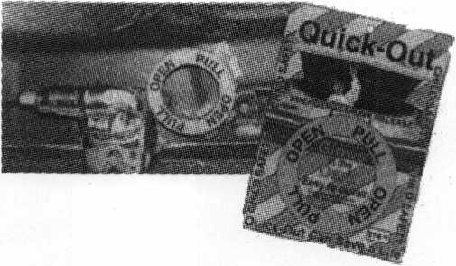

QUICK-OUT

Fits virtually all model autos. Easy to install. A child can release the trunk latch from inside the trunk to escape. Federal Law on new vehicles. A must for all others. This is probably the most important device in this catalog. Window posters and mounted locks available.

QUICK-OUT

Aable Locksmith  
86-19 97th Avenue  
Ozone Park, NY 11417  
718.847.1377 • FAX 718.847.0991

*March 2001* *Keynotes* !

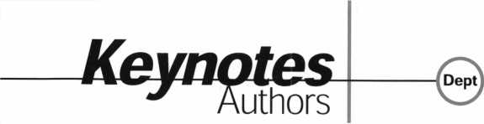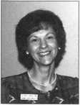

Claire L. Cohen, the second woman to become a CML, has been in locksmithing since 1977 and has been writing articles for Keynotes since 1987. She is also a contributing editor for Keynotes.

Donald B. Dennis, CPL has been dealing with the Locksmithing profession since 1972 with a four year apprenticeship in Albuquerque, New Mexico. He founded and has been the owner of Dennis Safe & Lock in Johnson City, Tennessee since 1977. He was the founder of the East Tennessee Locksmith Association in 1988 and is currently the Chairman of the Education Committee and editor of ETLA Newsletter.

B

Sal Dulcamara, CML, has been in the  
locksmith business for over 25 years. He is  
the president of All Pro Security, Inc. in  
Michigan and has been an ALOA member for  
18 years. A past president of the Locksmith  
Security Association of Michigan. Sal current-

ly serves as editor of the association newsletter.  
He was named “Keynotes Author of the Year” for 1996  
and 1997. He is also a contributing editor for Keynotes.

Tim McMullen oversees legislative affairs  
for ALOA. He is a graduate of the District  
of Columbia School of Law and has an  
extensive background in legislative work.

Kandy Simpson, CML, owns and operates

Baker's Safe & Lock in Houston, TX. He also serves as  
ALOA 'j- South Central Regional Director.



TURPI tO

WHOLESALE SERVICE

**800-848-9790**

**One Call  
Gets You...**

**Amsec**

**Gardall**

**•**

**Hayman**

**Meilink**

**Victor**

**•**

**Winchester**

**Plus Free Delivery  
From America's  
Largest Inventory  
of Safes.**

|  |  |
| --- | --- |
| Keynotes  Advertiser's Index | |
| Advertisers | Page |
| ALOA 2001 | IBC |
| BWD Automotive Corp. | 32 |
| Ilco | BC |
| Marray Enterprises Inc. | 9 |
| MasterLink Security Products | 35 |
| MLANJ | 35 |
| SAFETECH 2001 | IFC |
| Safe Technicians Ref Manual | 7 |
| SCHLAGE | 13 |
| SpeedyPik | 21 |
| STAM Insight | 5 |
| TURN 10 | 42 |

Keynotes

March 2001

BOARD

nominations

**What ALOA Board  
Positions Are Open  
and Where Am I  
Qualified  
to Run?**

There are currently six regional direc-  
tor positions open for election in addition  
to the position of President. ALOA mem-  
bers now elect the directors from their  
own regions. Only ALOA members from  
a region are eligible to run for the open  
position(s) in that region. And only mem-  
bers from the nominee's region will be  
receiving a ballot to vote for that candi-  
date. Members from any region are eli-  
gible to run for the President's position.  
You must have been an ALOA member  
for at least three years to run.

The following vacancies will exist for  
the election to be held before the ALOA  
2001 Convention:

**Southeast two directors  
North Central two directors  
Southwest two directors  
President**

If you have any questions,  
please contact Charles Gibson at (800)  
532-2562 or email [charlie@aloa.org](mailto:charlie@aloa.org)

On this page you will find  
the required nomination petition  
and on the following page, the nomina-  
tion form.

The following is the number of signa-  
tures required for each Board position:

**President  
Southeast Director  
North Central Director  
Southwest Director**

Associated Locksmiths of America, Inc. Board of Directors Nomination Petition

Please print legibly or type. This form can be reproduced if needed.



I, the undersigned, request that.  
the ballot for

be placed on

(name of nominee and member number)

for the election to be held at

(position for which individual is being nominated)

| the special meeting of ALOA members to be held in 2001 or any adjournment thereof,

am eligible to vote in theregion.

|  |  |  |  |
| --- | --- | --- | --- |
| PRINTED NAME  2 | MEMBER # |  | SIGNATURE |
| PRINTED NAME  3 | MEMBER # |  | SIGNATURE |
| PRINTED NAME  4 | MEMBER # |  | SIGNATURE |
| PRINTED NAME  5 | MEMBER # |  | SIGNATURE |
| PRINTED NAME  6 | MEMBER # |  | SIGNATURE |
| PRINTED NAME  7 | MEMBER # |  | SIGNATURE |
| PRINTED NAME  8 | MEMBER # |  | SIGNATURE |
| PRINTED NAME  9 | MEMBER # |  | SIGNATURE |
| PRINTED NAME  10 | MEMBER # |  | SIGNATURE |
| PRINTED NAME  11 | MEMBER # |  | SIGNATURE |
| PRINTED NAME  12 | MEMBER # | J | SIGNATURE |
| PRINTED NAME  13 | MEMBER # |  | SIGNATURE |
| PRINTED NAME  14 | MEMBER # |  | SIGNATURE |
| PRINTED NAME  15 | MEMBER # |  | SIGNATURE |
| PRINTED NAME  16 | MEMBER # |  | SIGNATURE |
| PRINTED NAME  17 | MEMBER # |  | SIGNATURE |
| PRINTED NAME  18 | MEMBER * |  | SIGNATURE |
| PRINTED NAME  19 | MEMBER # |  | SIGNATURE |
| PRINTED NAME  20 | MEMBER # |  | SIGNATURE |
| PRINTED NAME  21 | MEMBER # |  | SIGNATURE |
| PRINTED NAME  22 | MEMBER # |  | SIGNATURE |
| PRINTED NAME  23 | MEMBER # |  | SIGNATURE |
| PRINTED NAME  24 | MEMBER # |  | SIGNATURE |
| PRINTED NAME  25 | MEMBER # |  | SIGNATURE |
| PRINTED NAME | MEMBER # |  | SIGNATURE |

March 2001

Keynotes

YOUR COMMITMENT TO ALOA BOARD SERVICE

fPlease read carefully and sign where indicated.}

The responsibilities of an ALOA board member include contributing a moderate amount of personal time, and a significant degree of professional guidance and expertise to the organization.

You will be expected to come to board meetings and the annual membership meeting. You will need to be prepared to sensibly discuss matters of great importance to your profession and participate in setting policy as part of a governing body. Your course of action during your tenure on the ALOA board should be guided by fair minded, constructive goals pertaining to matters of consequence for ALOA and for the industry. Your contributions are expected to benefit ALOA as a whole, taking individual member rights and concerns into account, but free of the taint of partisan politics or personal gain.

On a practical note: ALOA board members are expected to behave and dress professionally at all times, especially when actively representing the association. ALOA board members are required to participate in two board meetings per year, of three or four days in length, one each fall and spring. Board members are also asked to attend the annual convention and are required to attend the annual membership meeting. Board members may also be asked on a voluntary basis, to represent ALOA at related local, state or regional functions, including serving in the ALOA Booth and otherwise promoting ALOA. When travel is required for a board member, expenses covered by ALOA include lodging, travel and a reasonable per diem. The Board has stipulated that assigned travel will be reimbursed at the lesser of the 30-day advance tourist class airfare in effect at the time of travel or the current per-mile rate for travel by personal automobile. Spouse expenses, including extra room charges, etc., are the individual's responsibility.

• • •

I have read and understand the above responsibilities of an ALOA board member, and agree to commit my time and energies as needed. I certify all of the information contained on this form and supporting documentation to be true and complete.

I can be contacted with questions at:

Address Phone#

Signed: Date

Please attach a recent photograph of yourself and retain a copy of this profile for your own files. This profile and all supporting documentation should be submitted no later than March 31, 2001:

Mail to:

Nominee Profile

Secretary of the Board of Directors  
Associated Locksmiths of America  
3003 Live Oak Street  
Dallas, TX 75204-8186

REV. 11/00

***Keynotes***

March 2001

gHEC

m

mem

"* Nl§f i§ip“- >*#^ S

*^:’: >' ' 'v iff)



one.

do you know what to expect

when tomorrow arrives?



<T3

E

OJ

<N

vO

tO

<N

CM

m

to

witness the unexpected july 15-22

£ O

at baltimore convention center. .



Everest key systems are available in SFIC and Full Size 1C, mortise, rim and key in knobAever formats.

It’s time to climb with Everest" key control systems.

Everest truly represents the new standard of key control for the industry. It offers Schlage customers the benefits of heightened security without the high price. Because all Everest keys are patented, they can only be copied by Schlage authorized locksmiths. This gives Schlage customers one secure source for all keys, cylinders, additional locks and accessories. Whether you want the convenience of open keyways or the additional security of restricted keyways, Everest is the perfect solution. Locksmiths have trusted Schlage for new ideas and security solutions since 1925. Visit Schlage at [www.schlage.com](http://www.schlage.com).

SCHLAGE.

THE KEY TO SECURITY™

(/R) Security & Safety, is a sector of Ingersoll-Rand Company. Other industry leading IR brands include Von Duprin, LCN, Steelcraft, Glynn-Johnson, Dor-O-Matic, Locknetics and Recognition Systems. The Everest keybow is a registered trademark of the Schlage Lock Company. © 2001 Ingersoll-Rand

